Discover Delhi with INTRO TRAVELS INDIA
Delhi, the capital city of India, is a perfect blend of history, culture, modern lifestyle, food, shopping, and architecture. From majestic Mughal monuments and vibrant markets to luxury malls and bustling nightlife, Delhi offers an unforgettable travel experience for every traveler.
Whether you are planning a family vacation, heritage tour, shopping trip, food adventure, or weekend getaway, Delhi welcomes you with rich traditions and modern attractions.

Why Visit Delhi?
- Historic monuments & UNESCO sites
- Rich Mughal and colonial heritage
- Famous street food & restaurants
- Vibrant markets & luxury shopping
- Modern cafés, nightlife & culture
- Beautiful temples & gardens
- Gateway to North India tourism
- Perfect blend of old and new India

Top Tourist Attractions in Delhi
1. India Gate
One of Delhi’s most iconic landmarks and war memorial.
Highlights:
- Evening lighting
- Beautiful gardens
- Family picnic spot
- Rajpath views
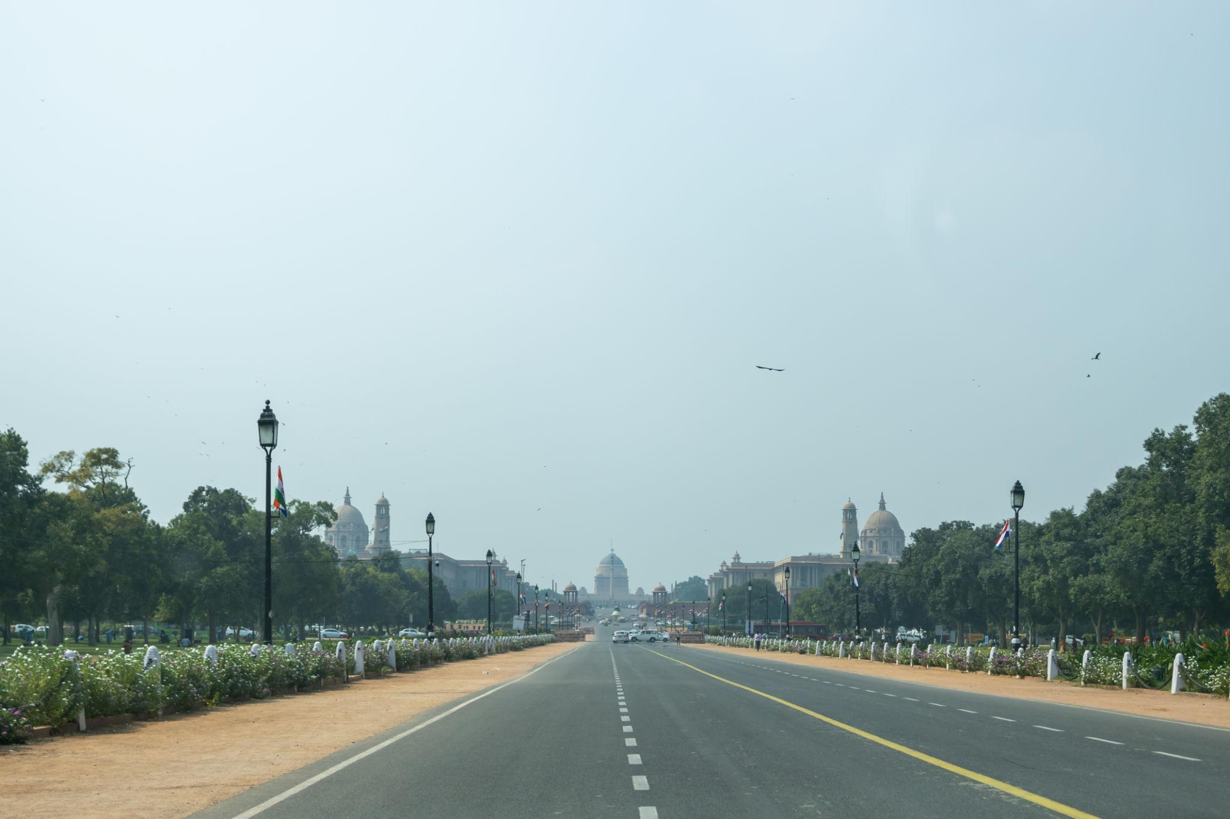
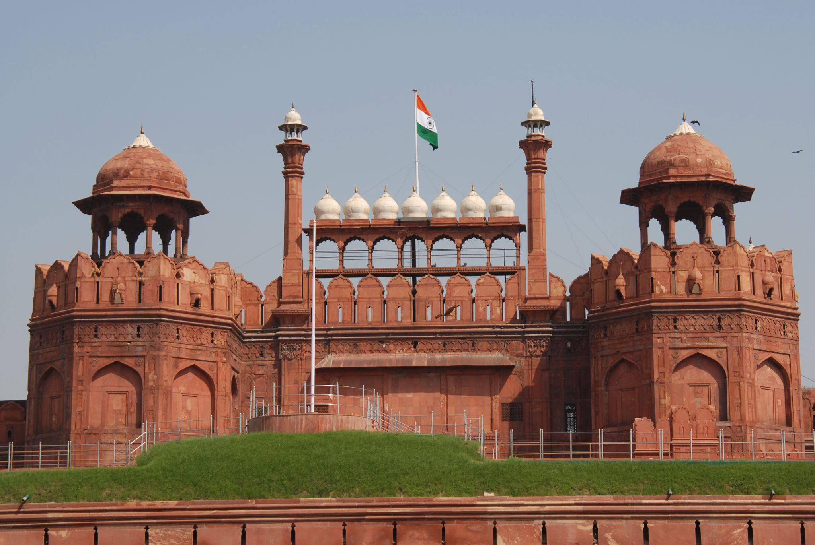
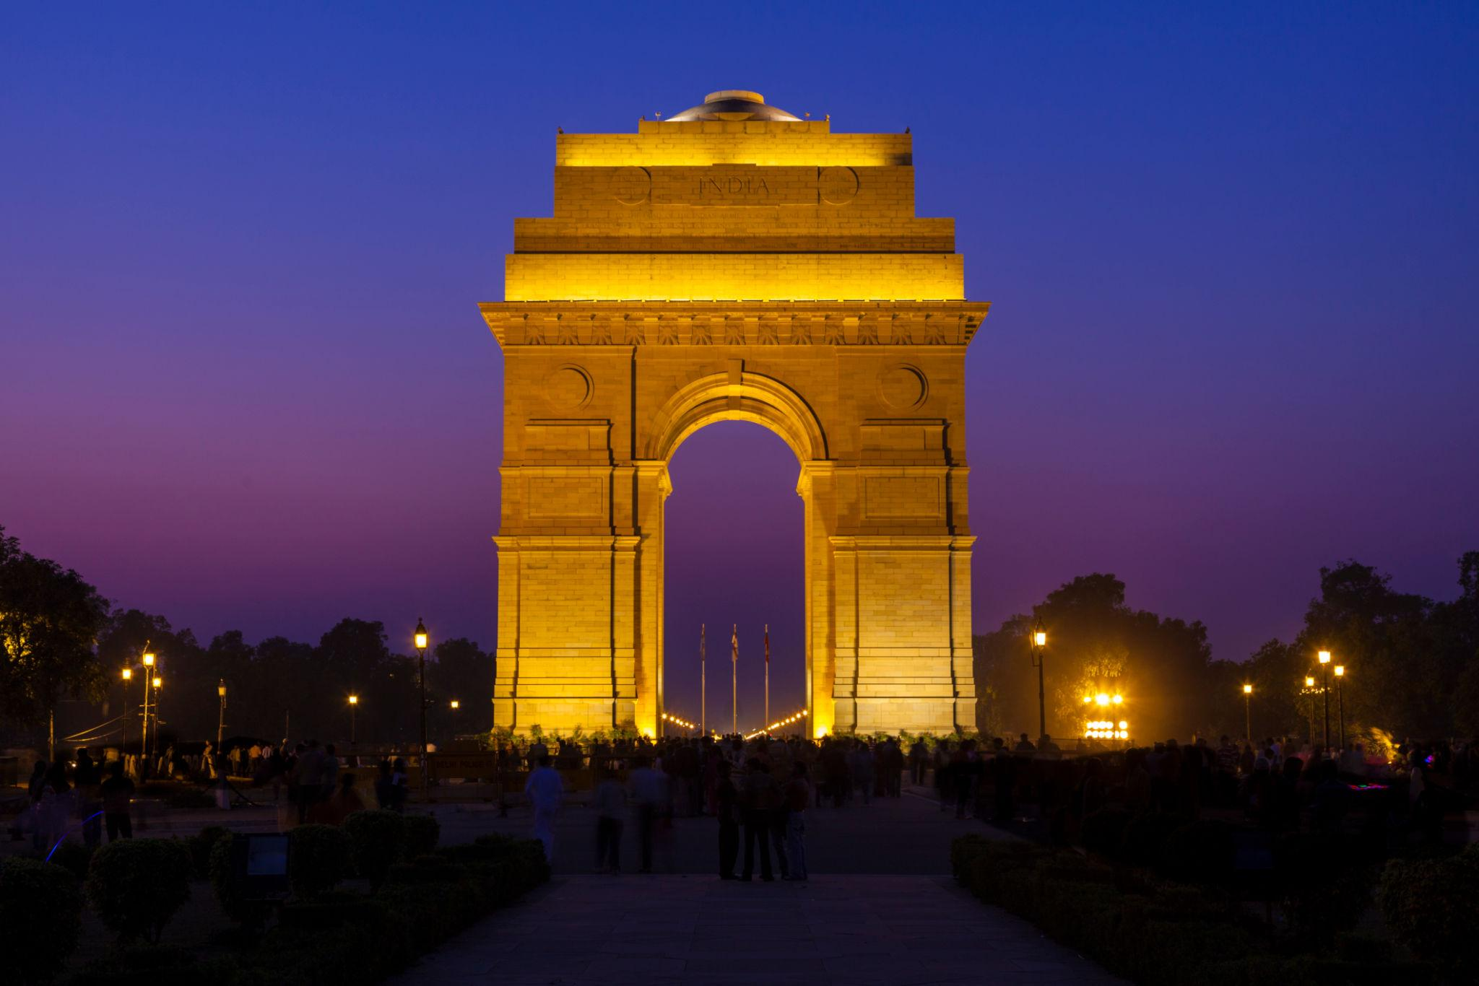
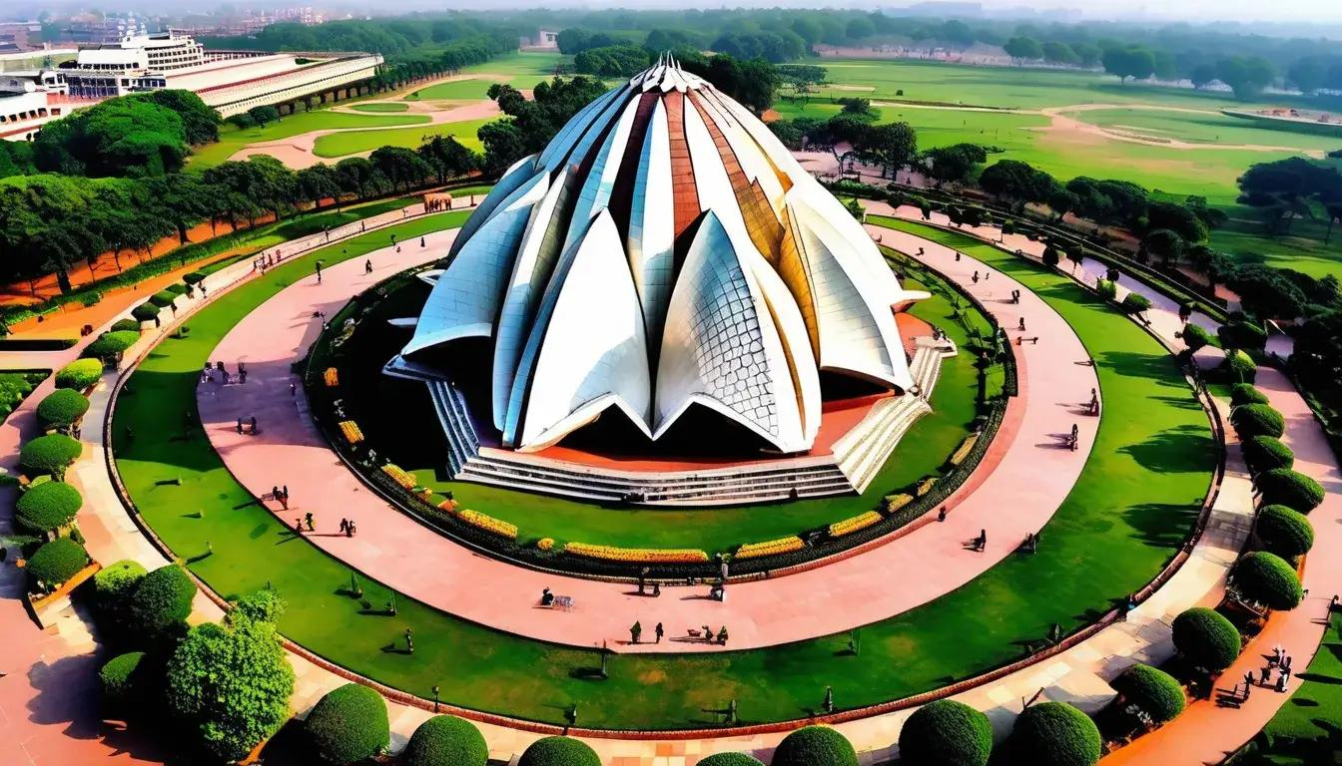
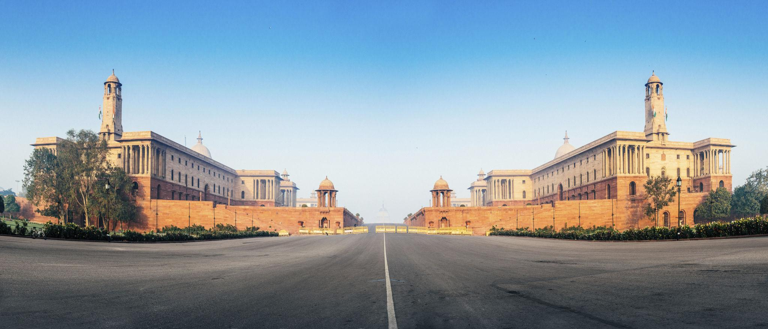
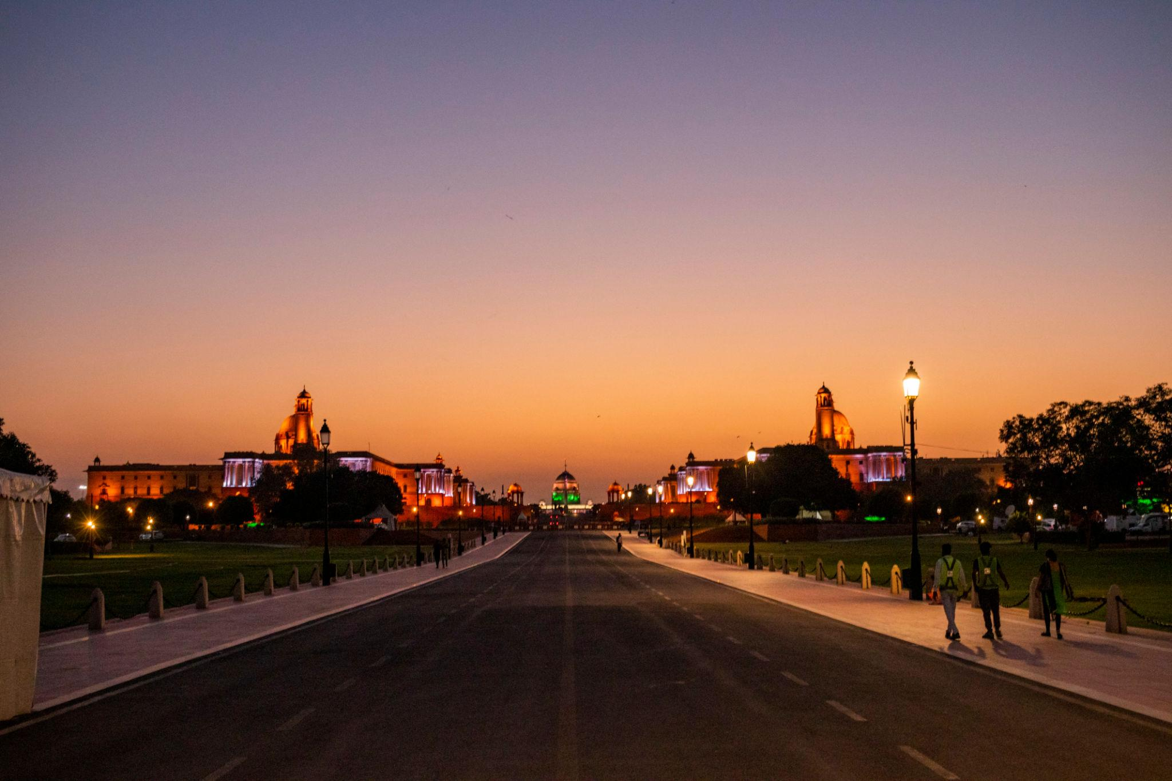
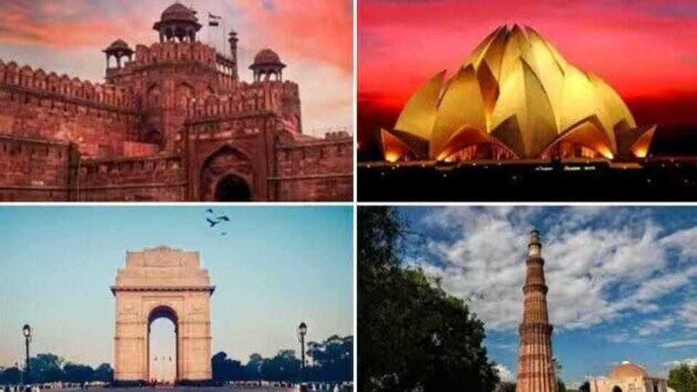

2. Red Fort
A UNESCO World Heritage Site built by Mughal Emperor Shah Jahan.
Known for:
- Mughal architecture
- Historic significance
- Independence Day celebrations
- Light & sound show
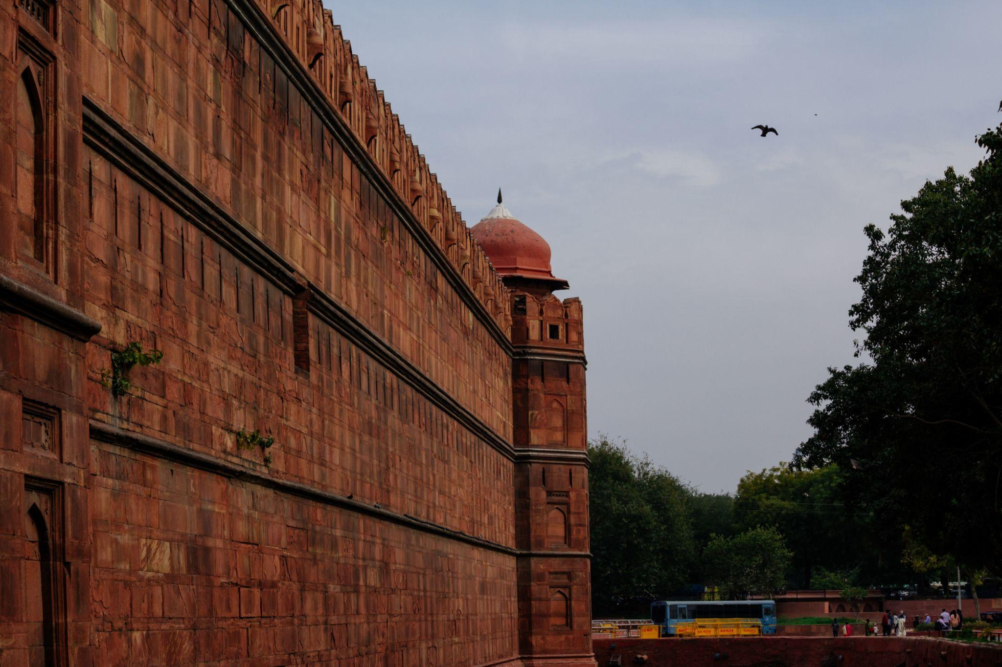
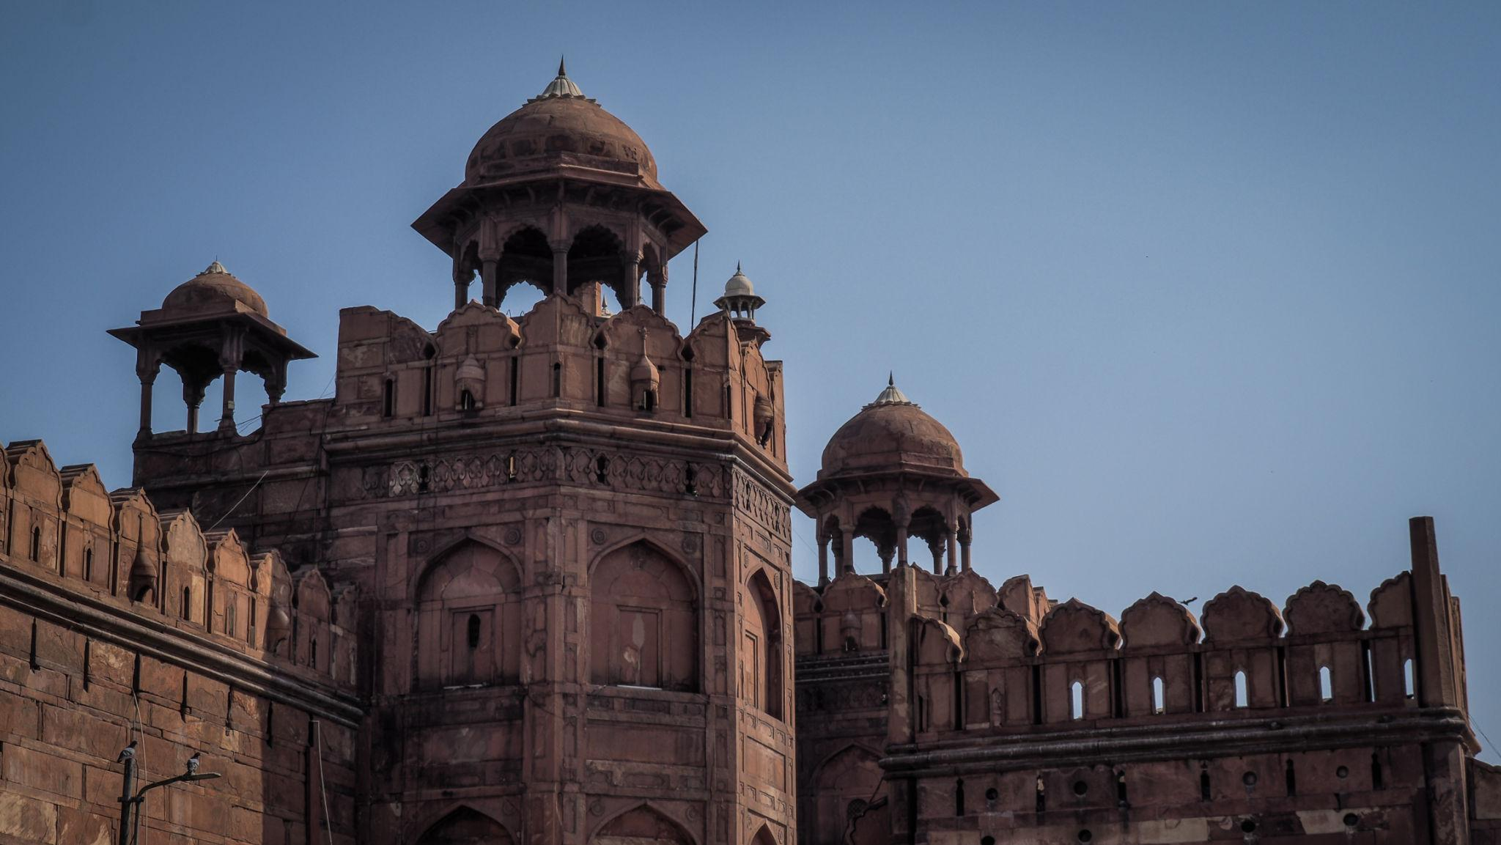
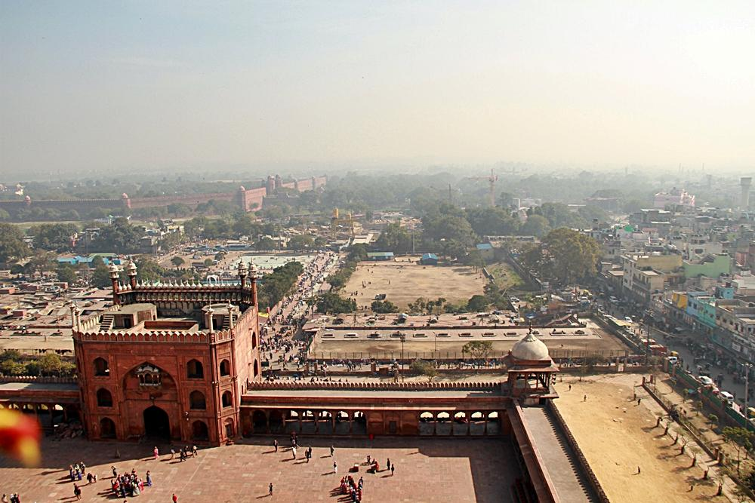
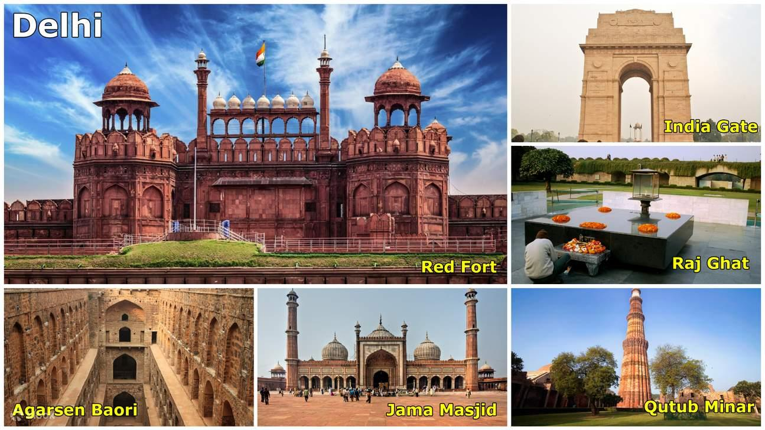

3. Qutub Minar
The tallest brick minaret in the world and a UNESCO heritage monument.
Highlights:
- Ancient Indo-Islamic architecture
- Historic ruins
- Beautiful gardens
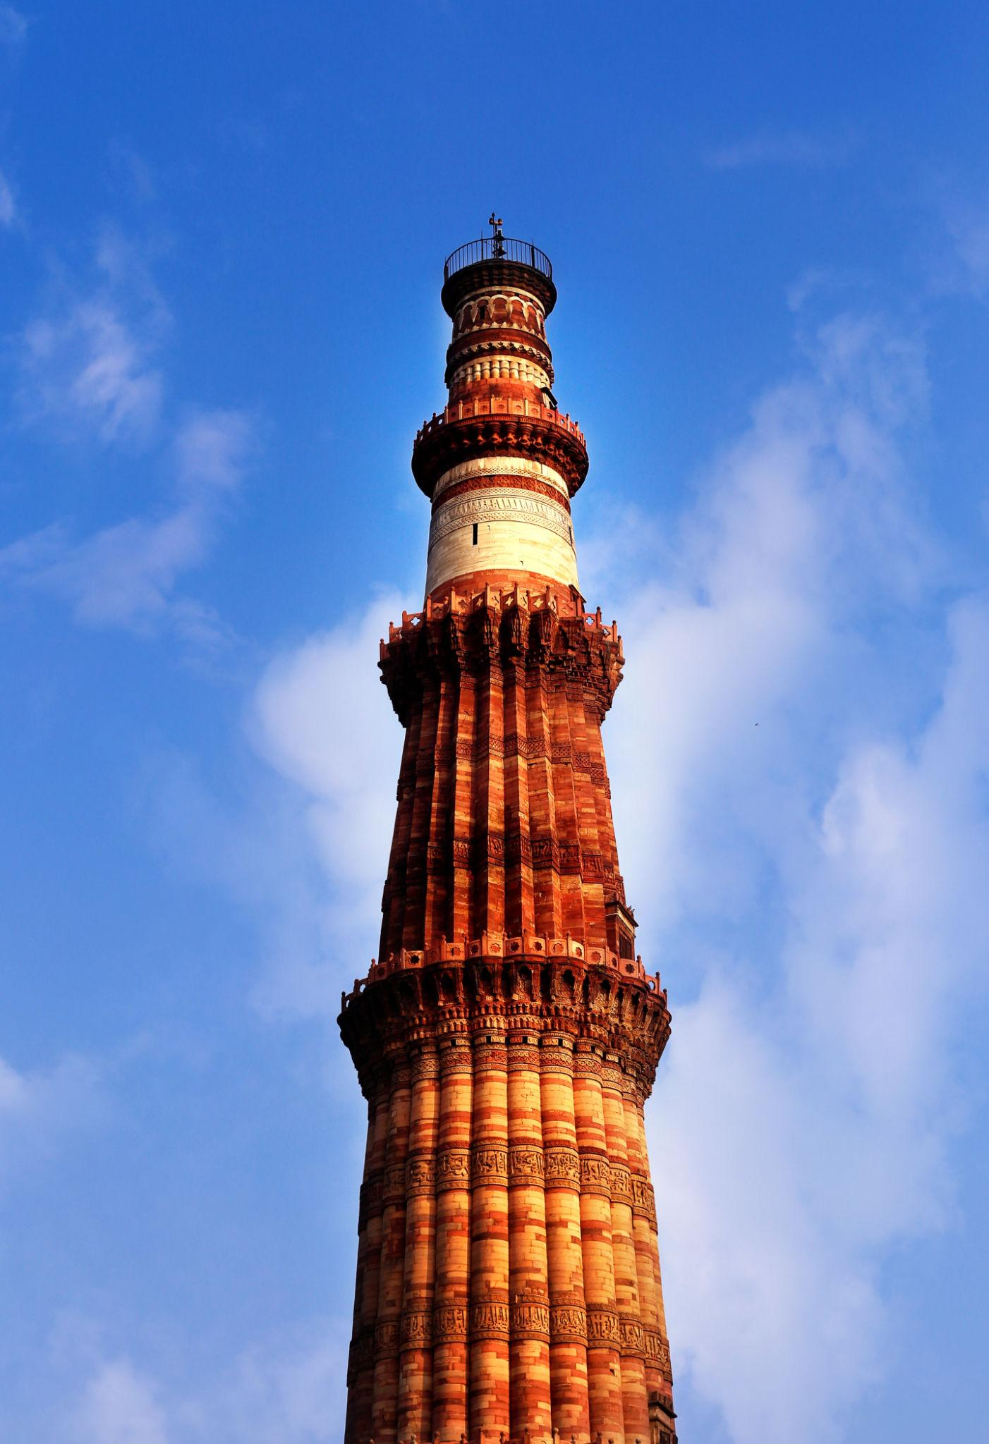
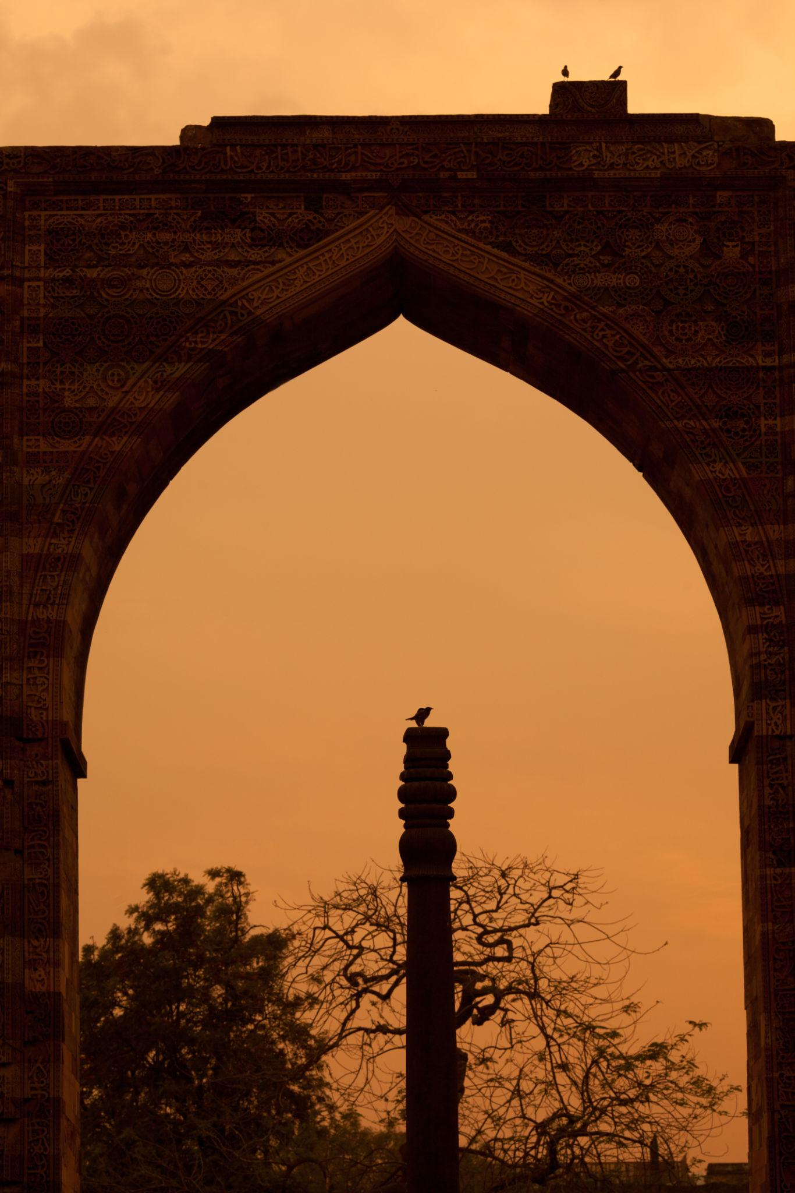
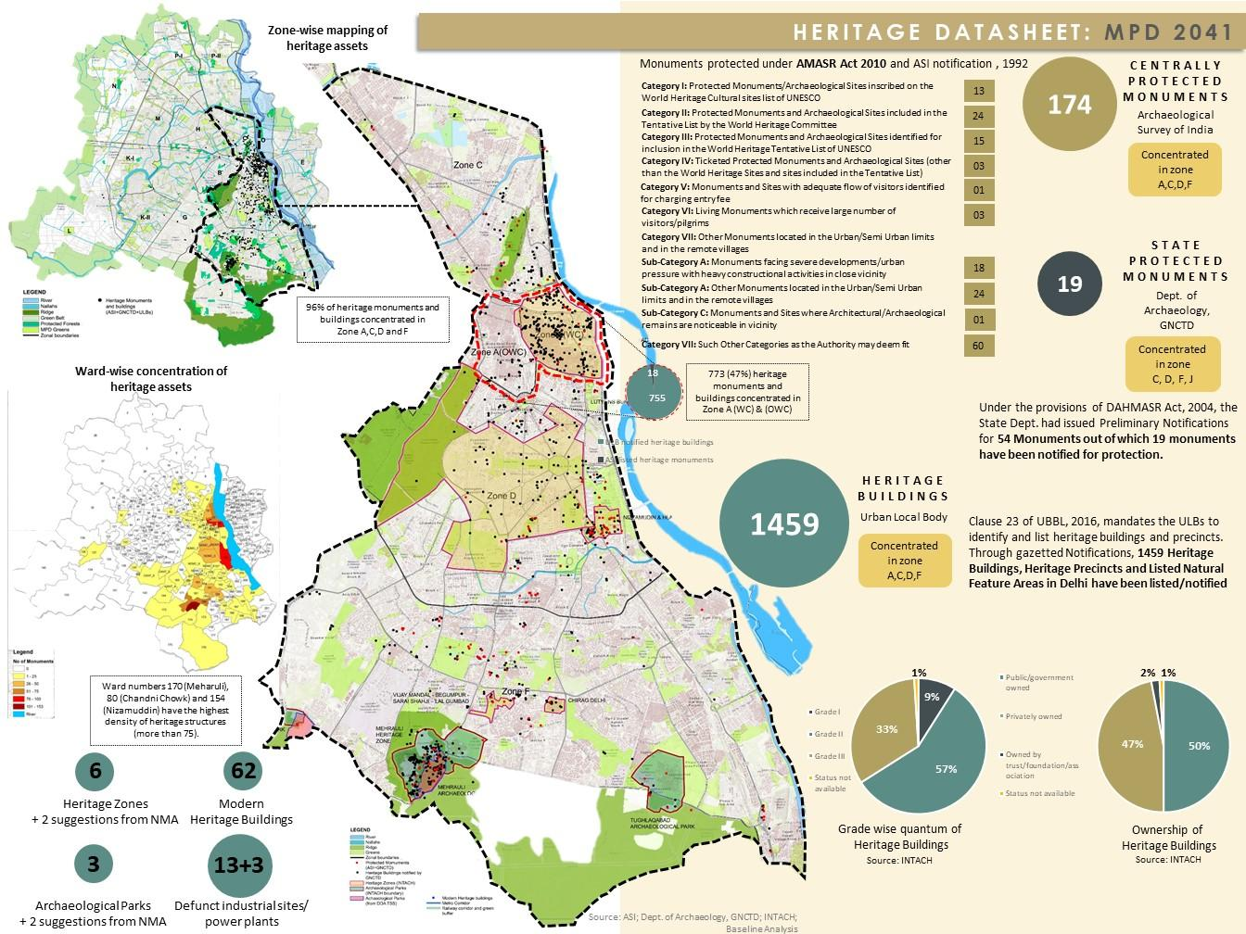
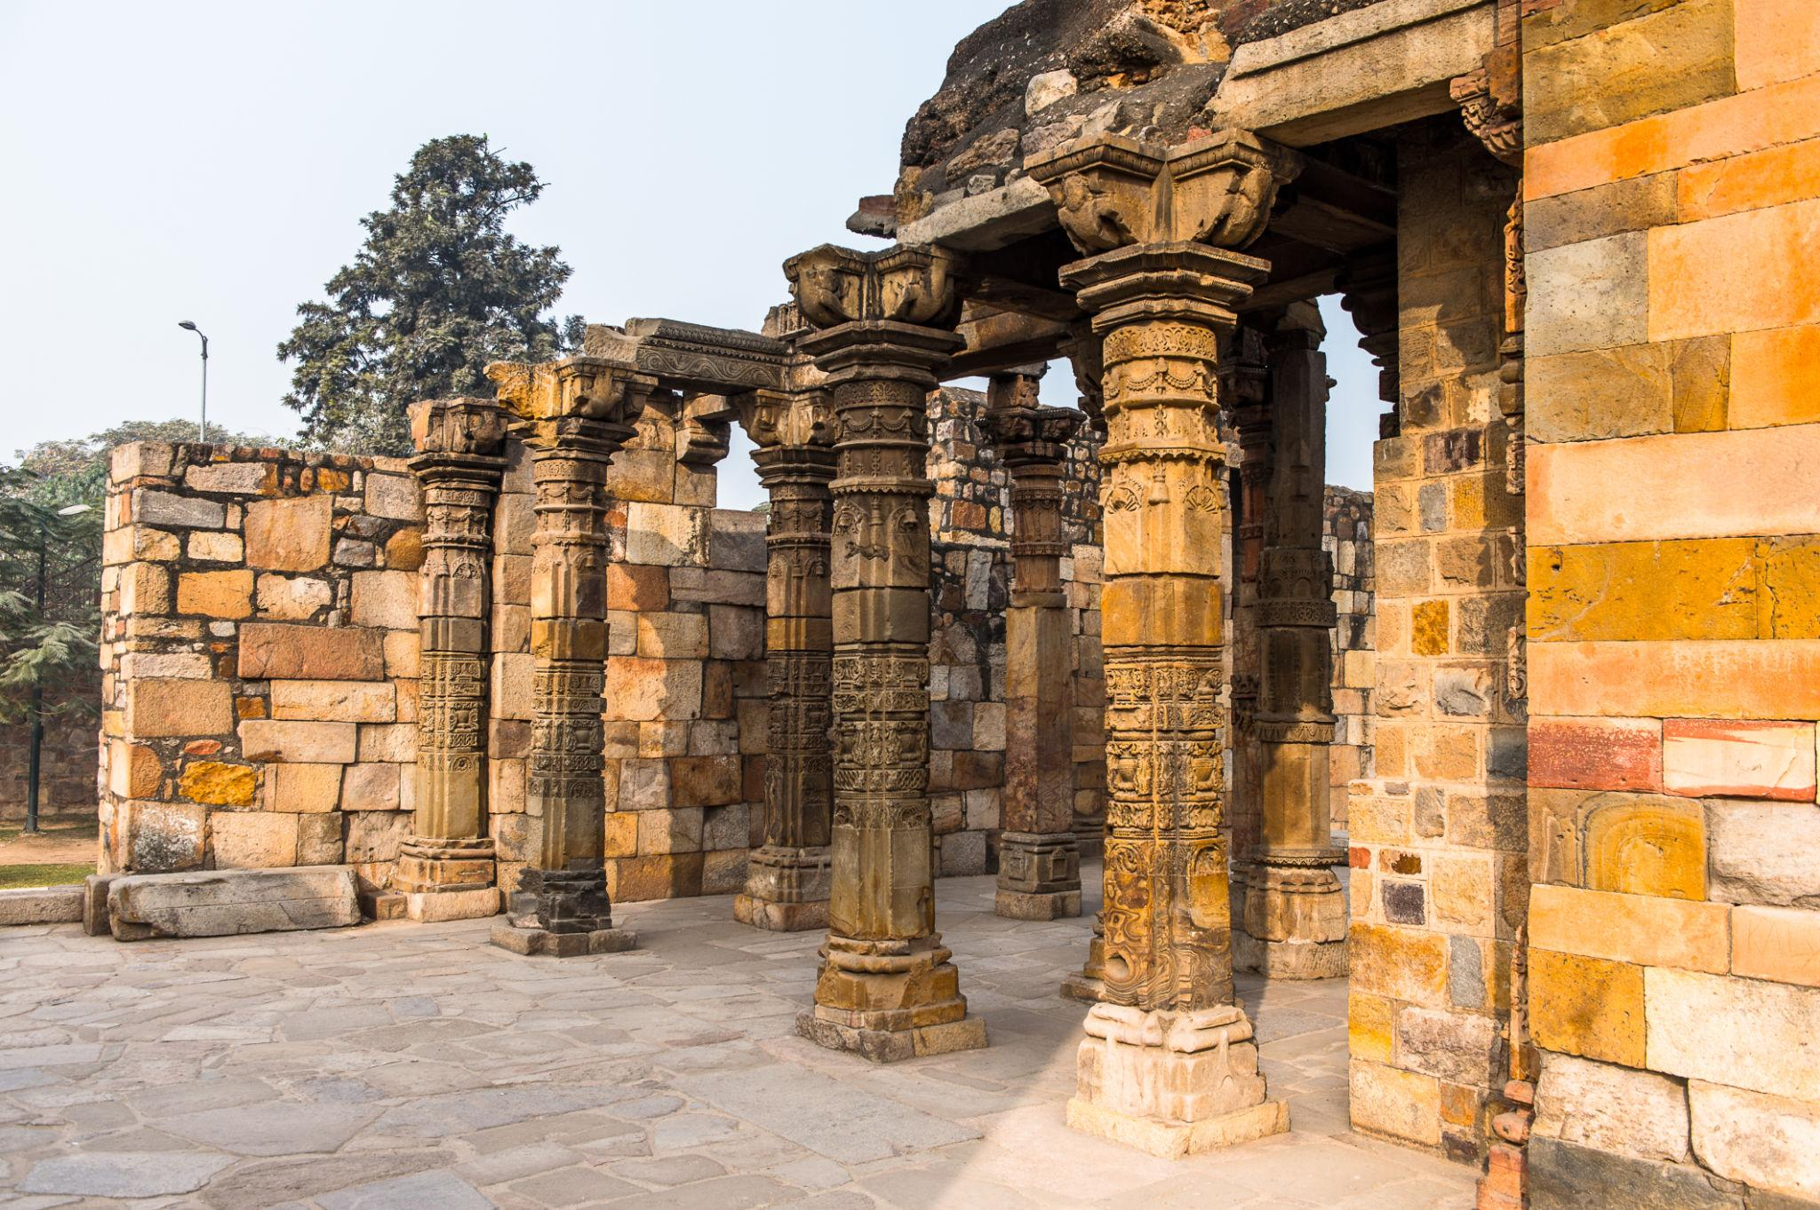

4. Lotus Temple
A world-famous Baháʼí House of Worship known for its lotus-shaped architecture.
Best for:
- Peaceful meditation
- Photography
- Architectural beauty
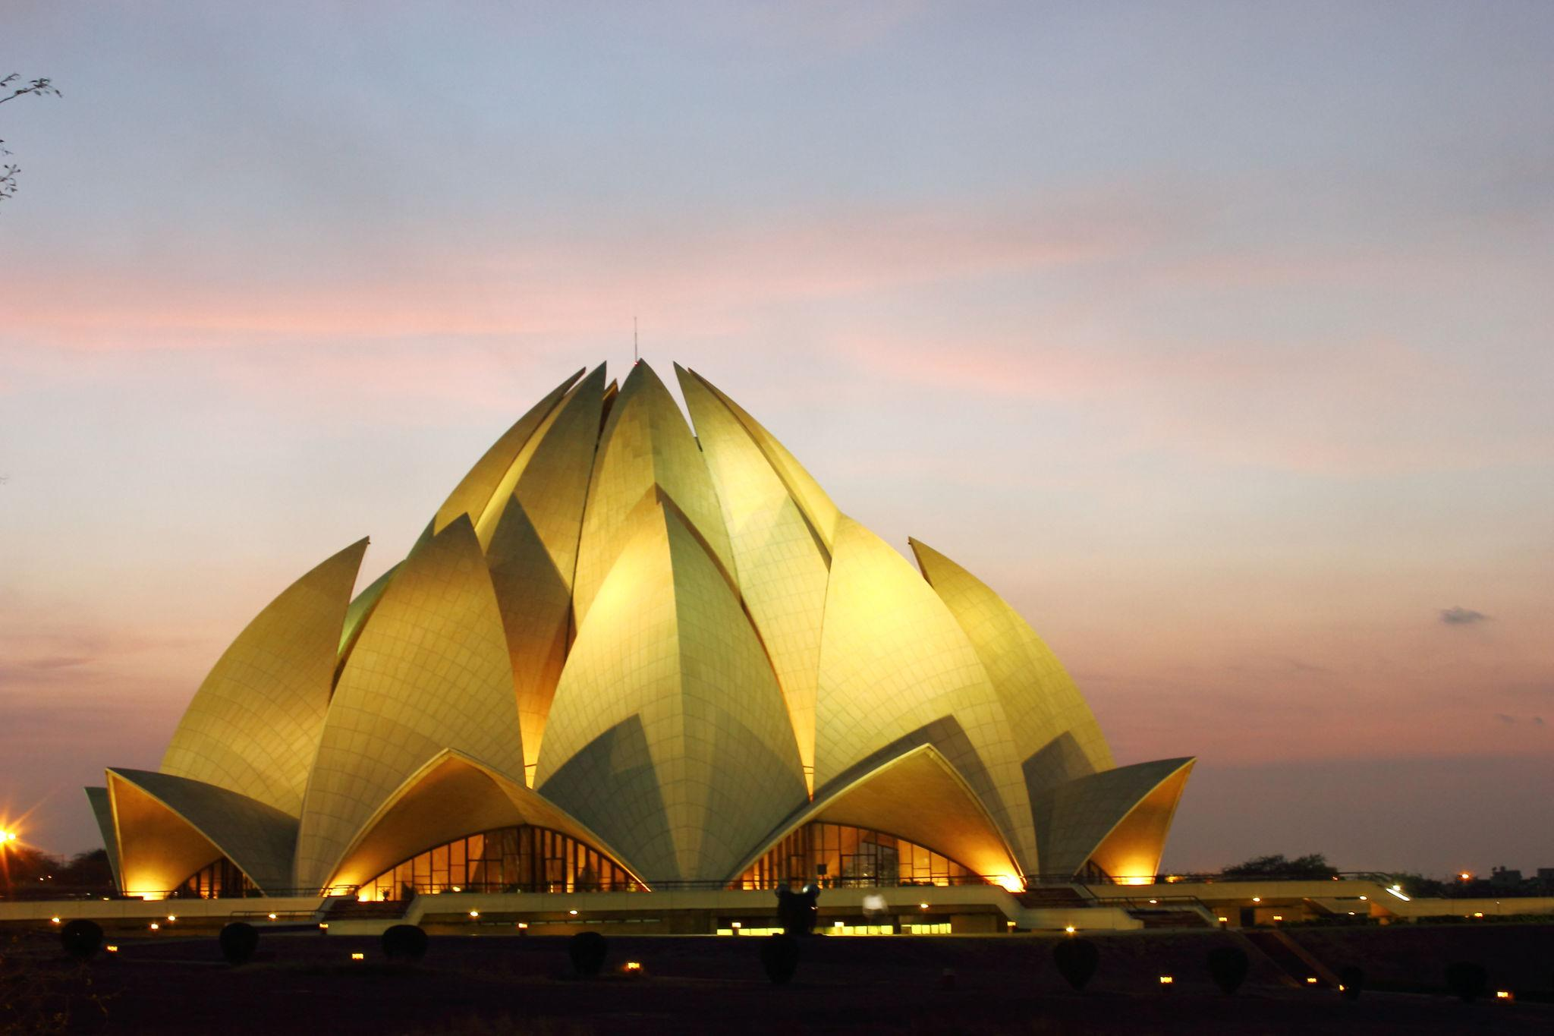
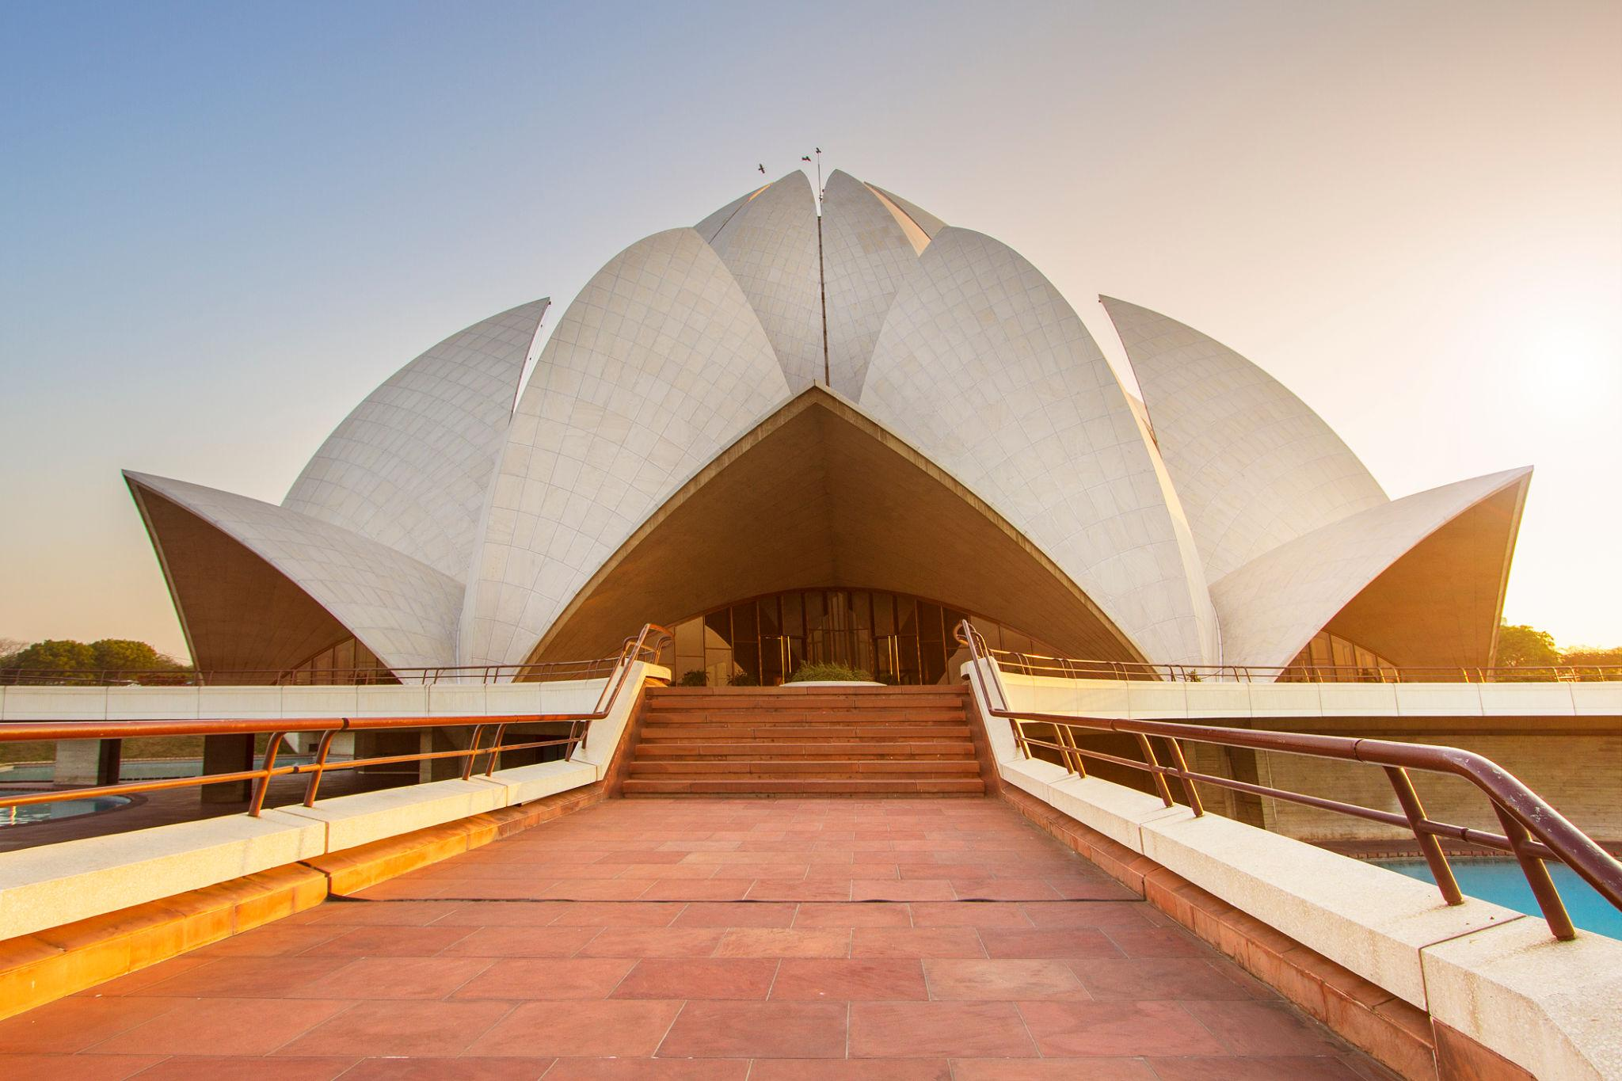
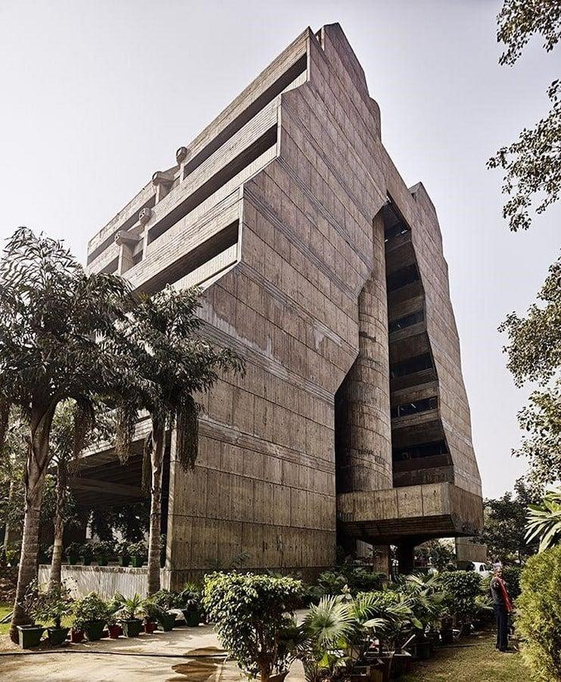
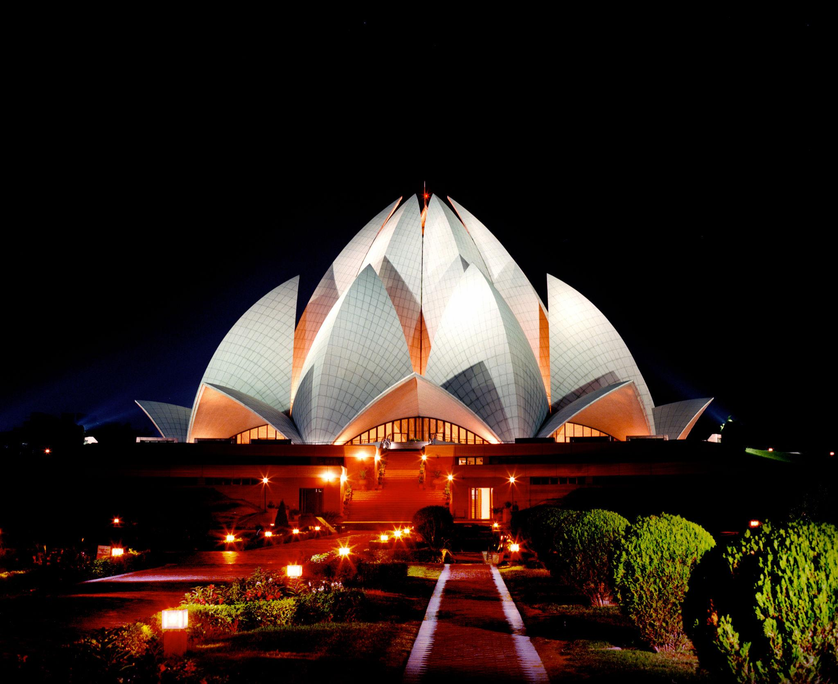
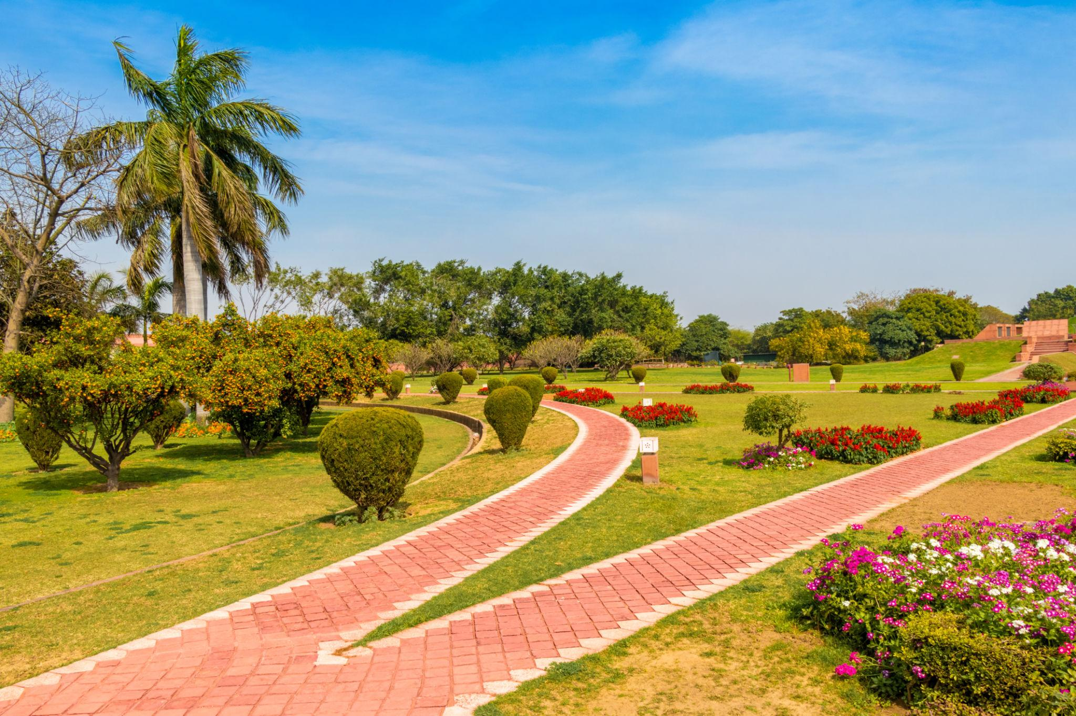
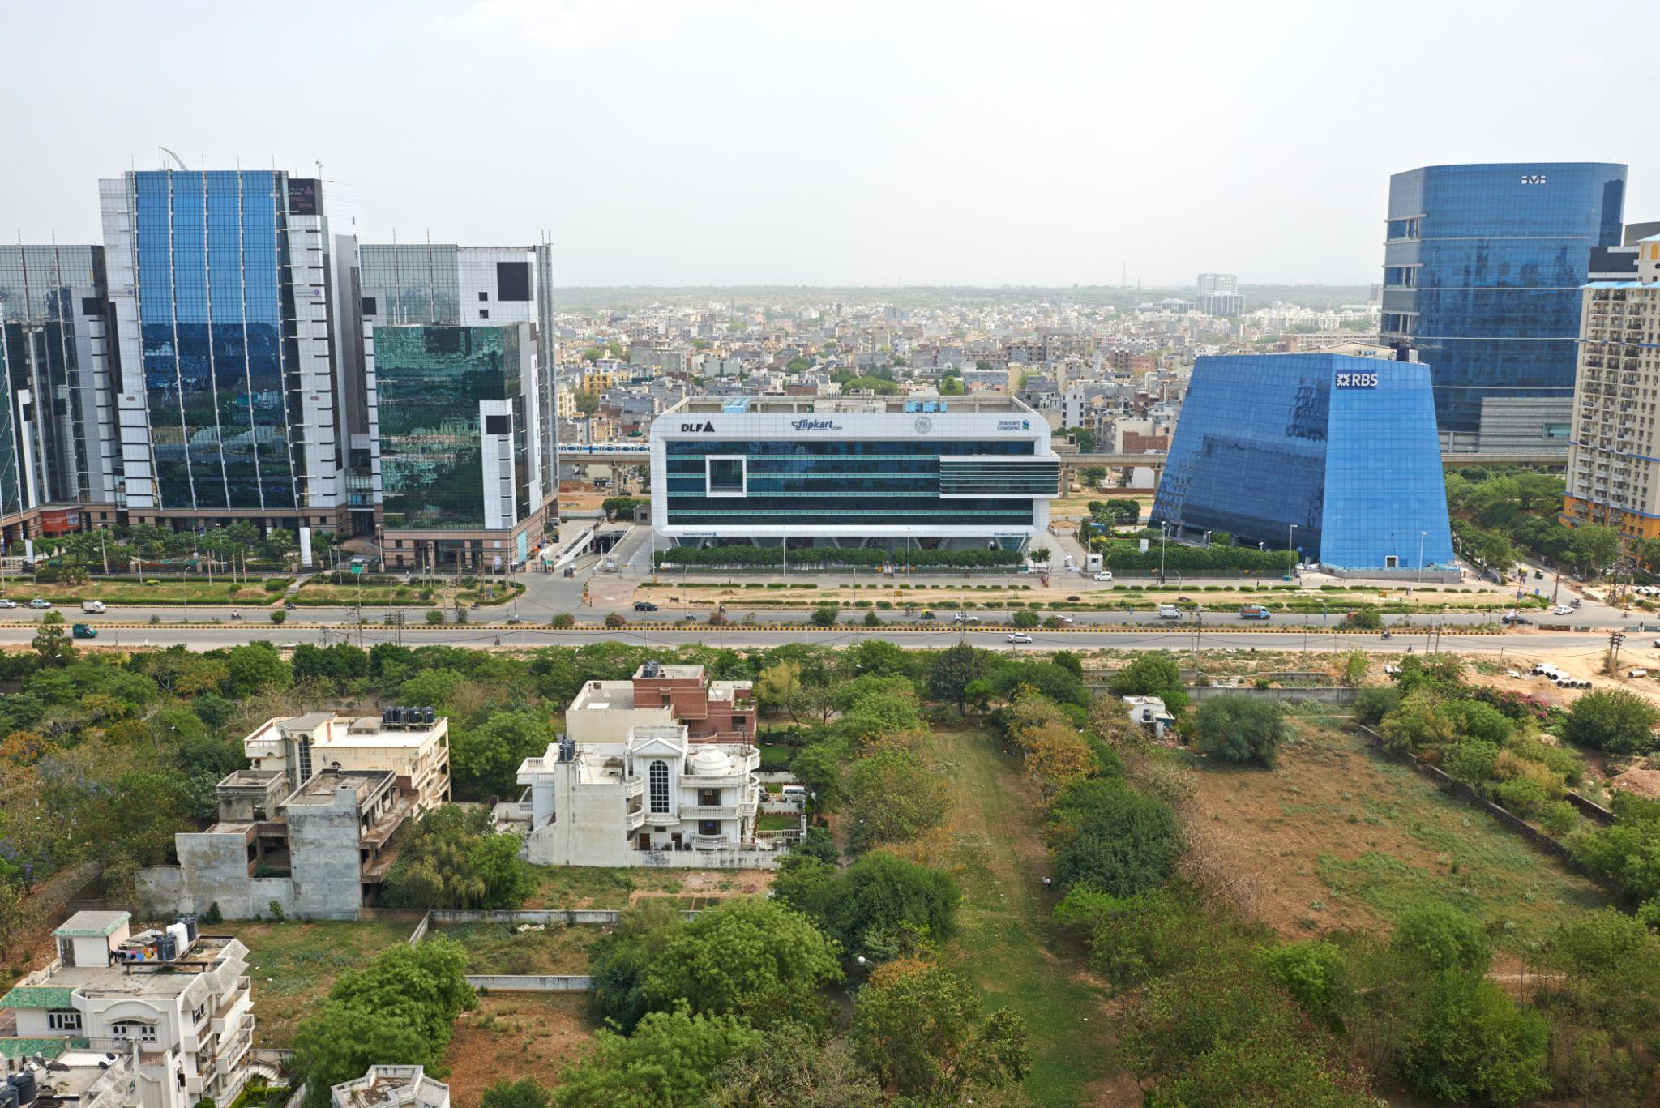

5. Humayun's Tomb
A UNESCO World Heritage Site and one of Delhi’s finest Mughal monuments.
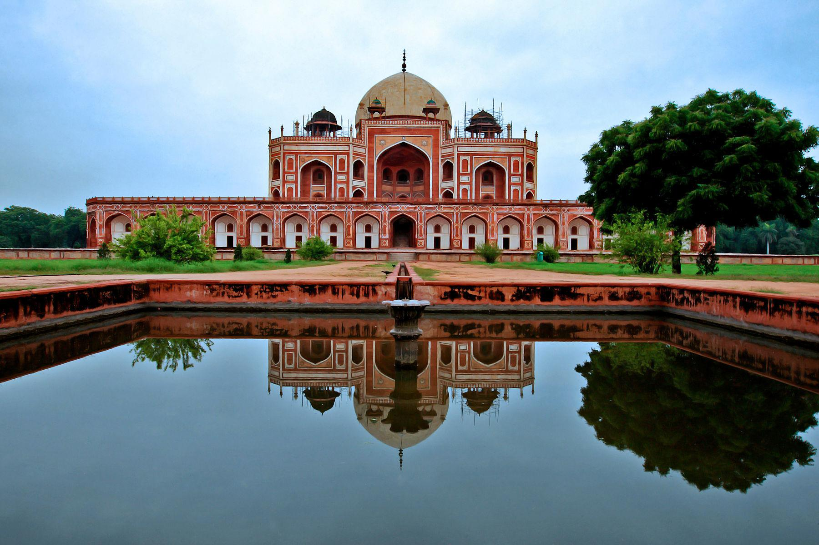
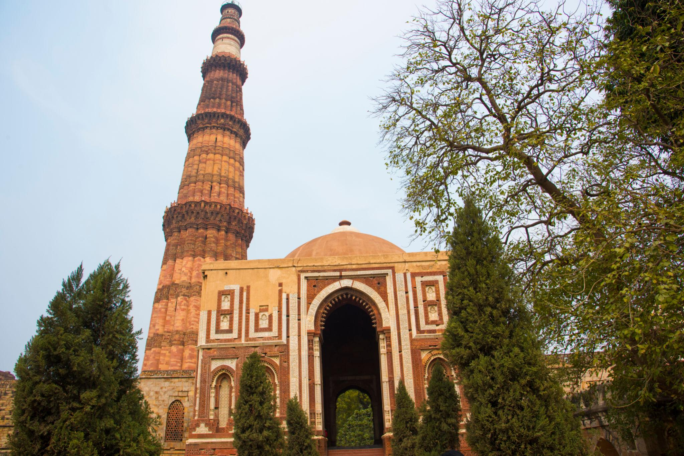
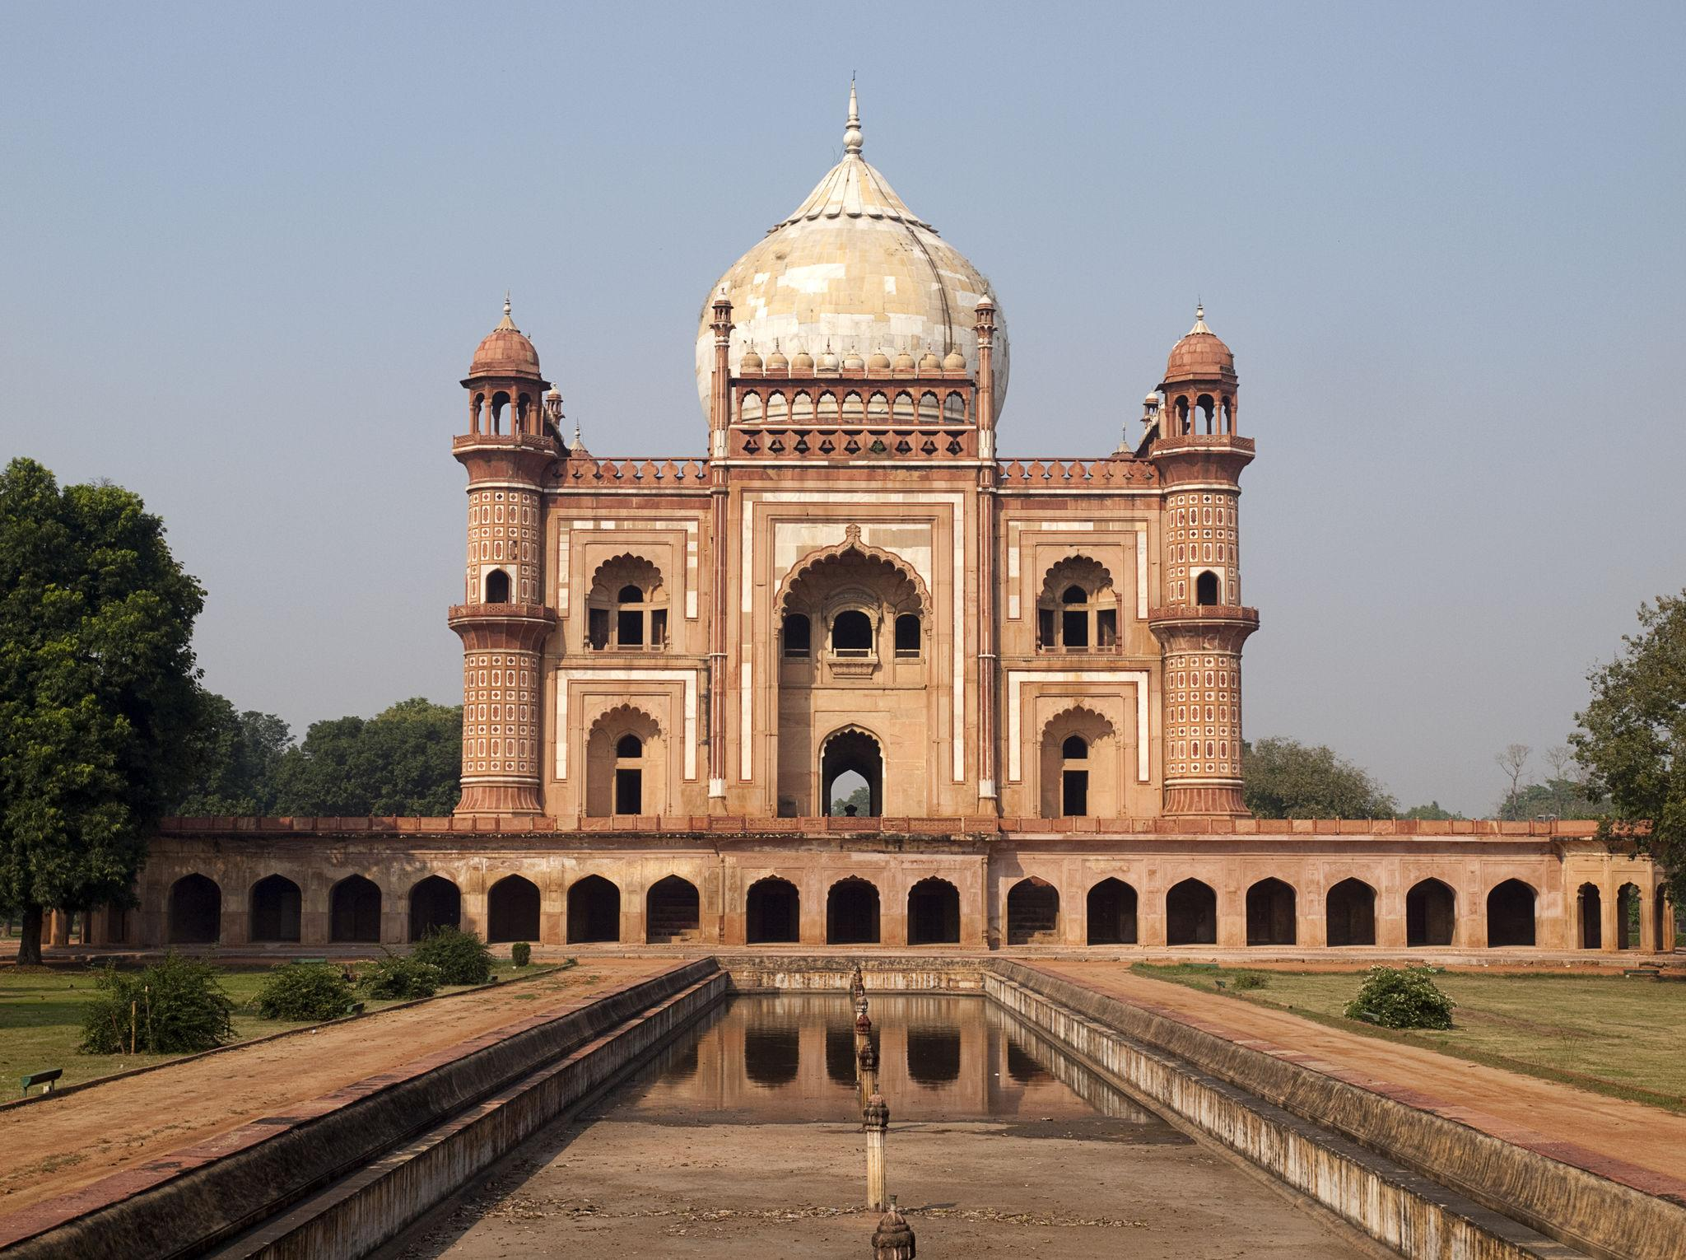
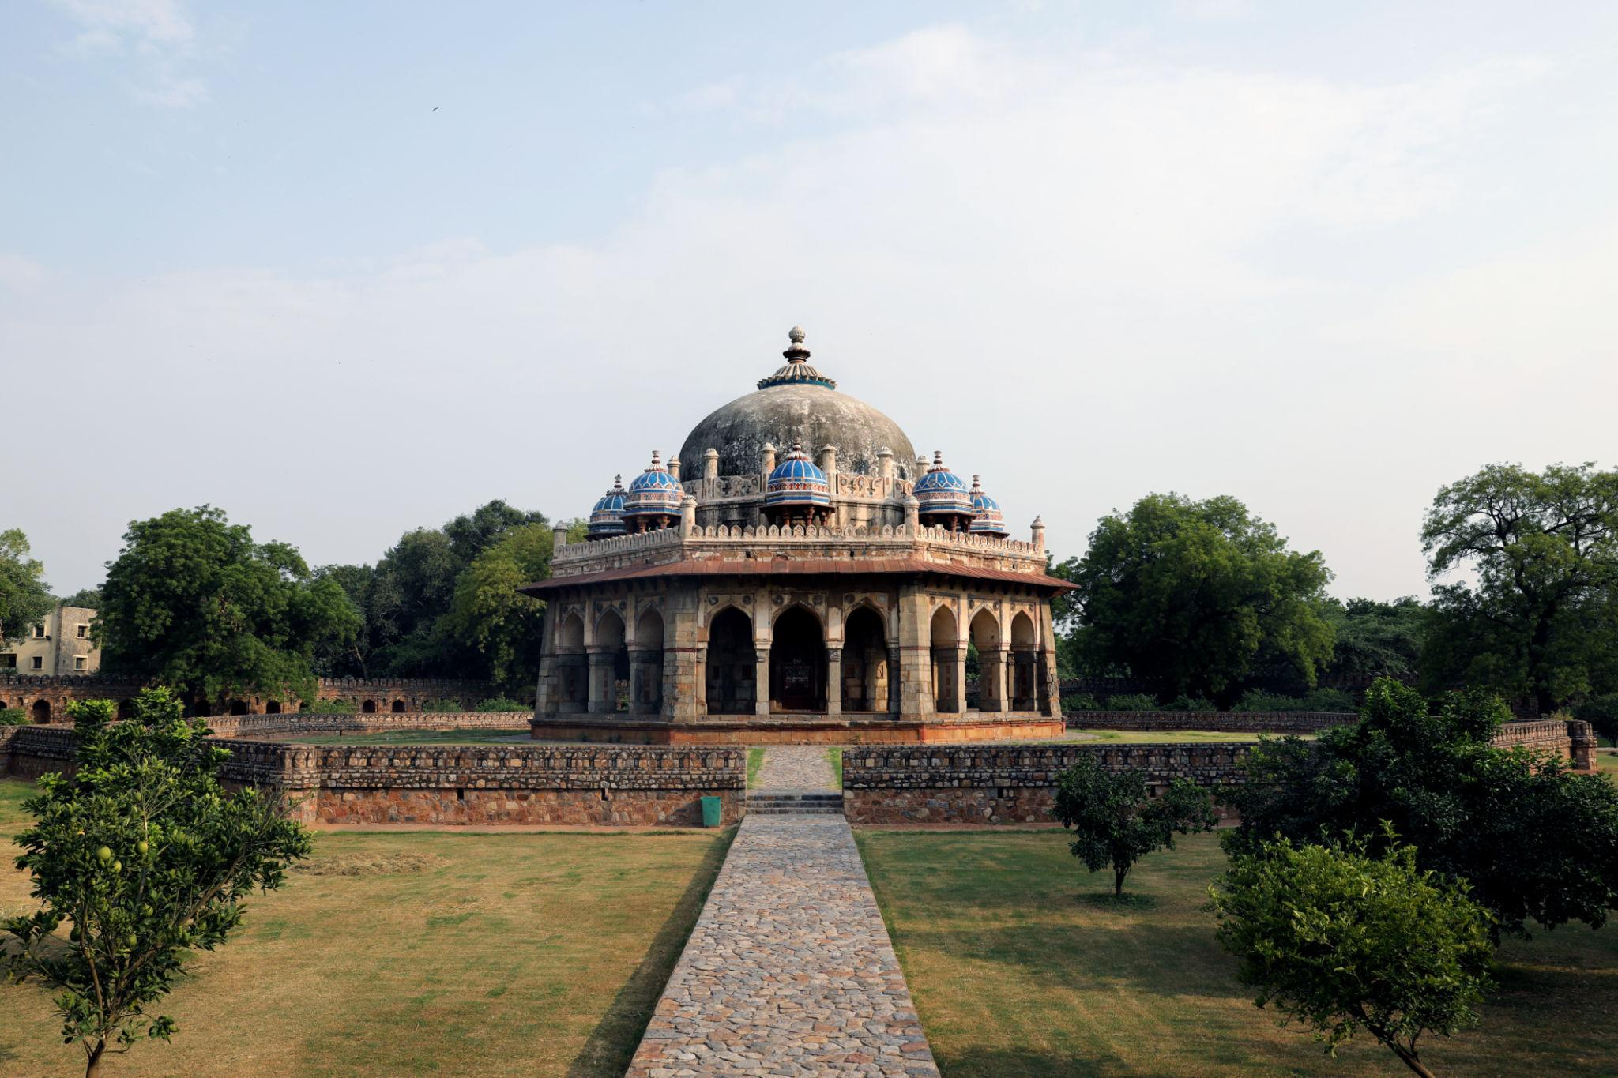
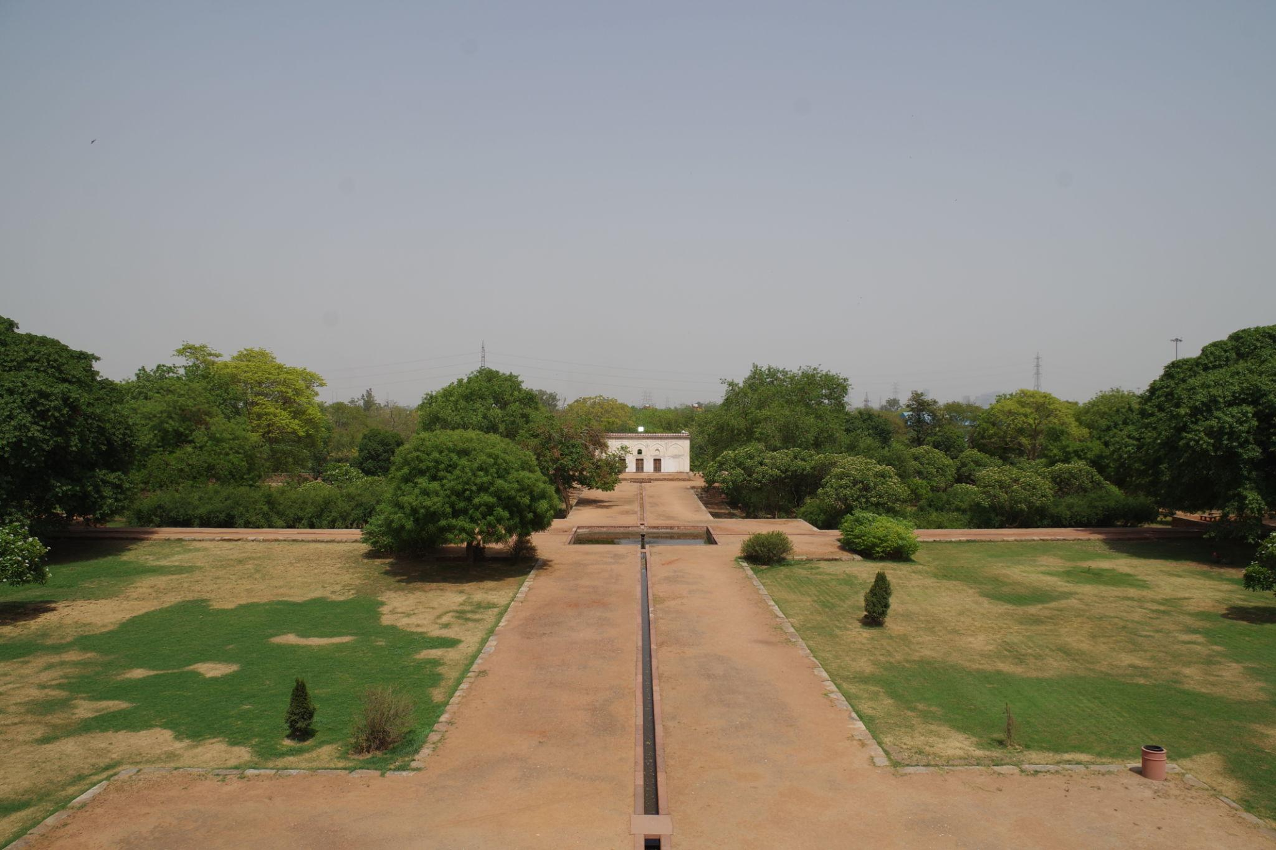
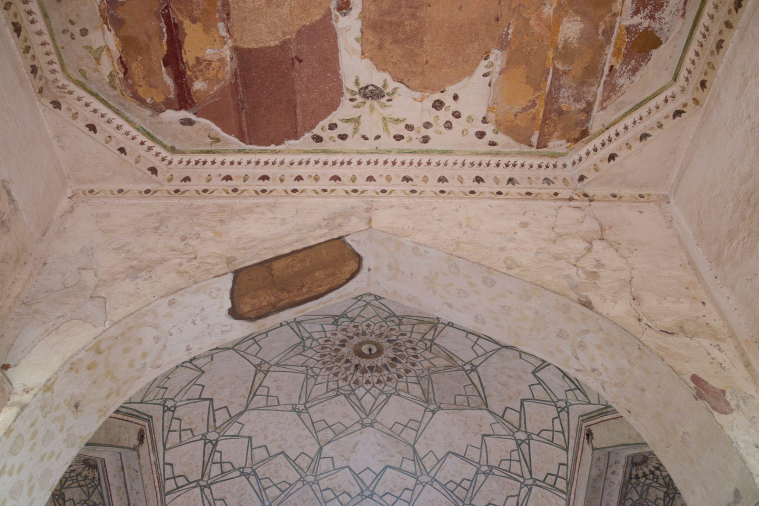

6. Akshardham Temple
One of the largest Hindu temple complexes in the world.
Highlights:
- Stunning carvings
- Musical fountain show
- Cultural exhibitions
- Spiritual atmosphere
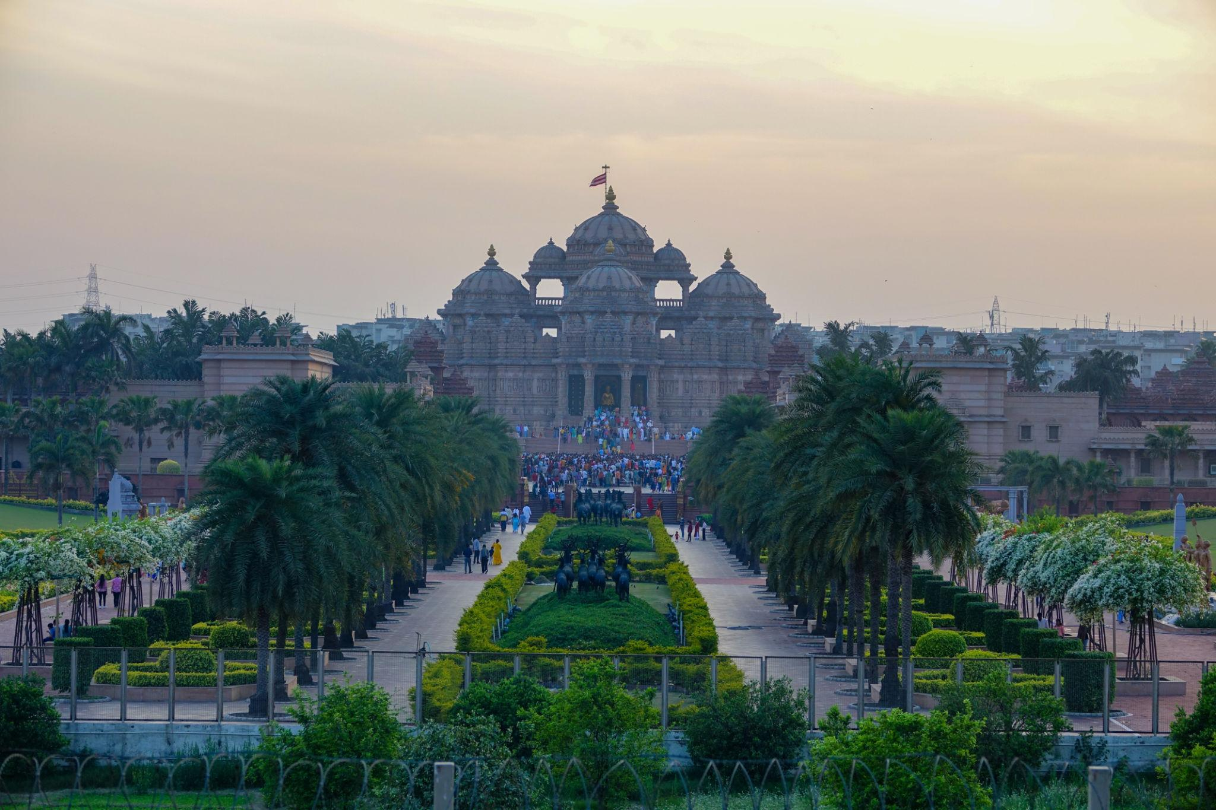
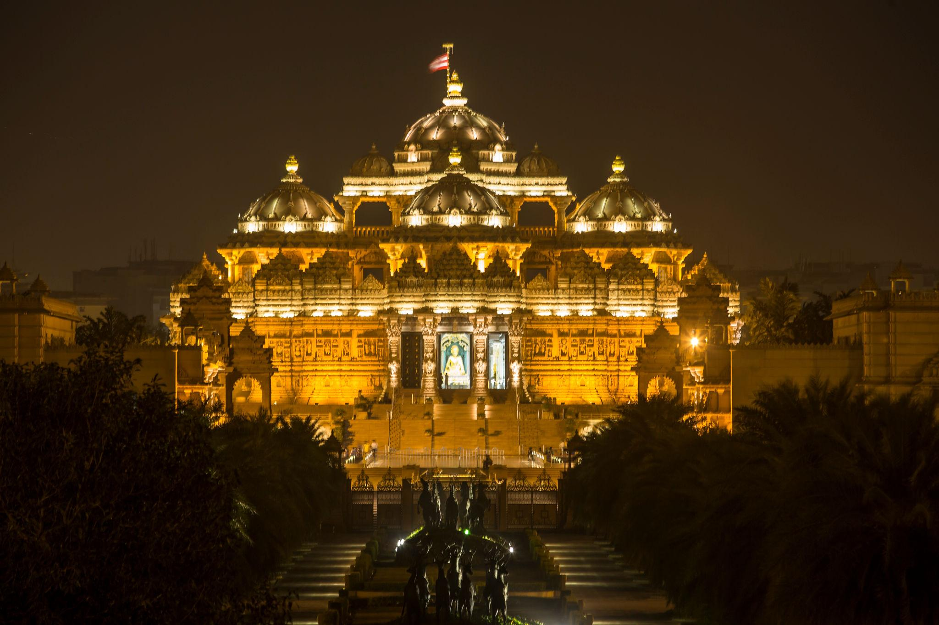
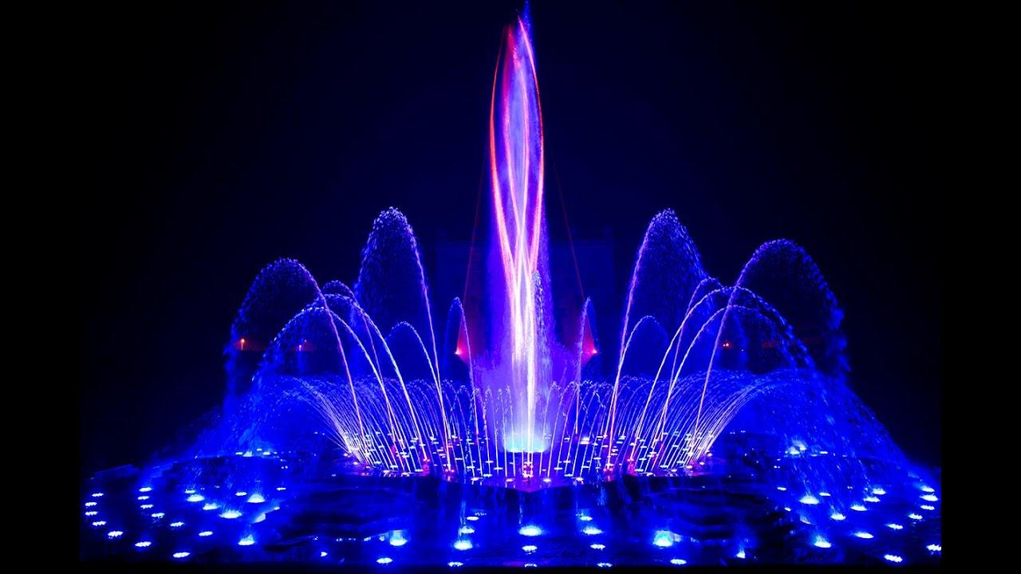
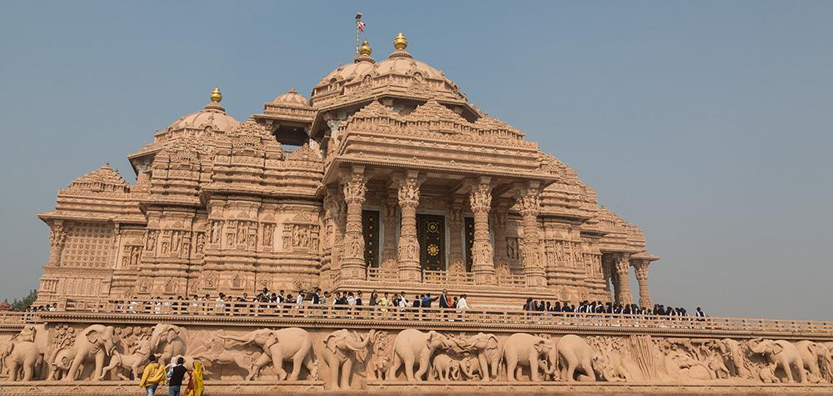
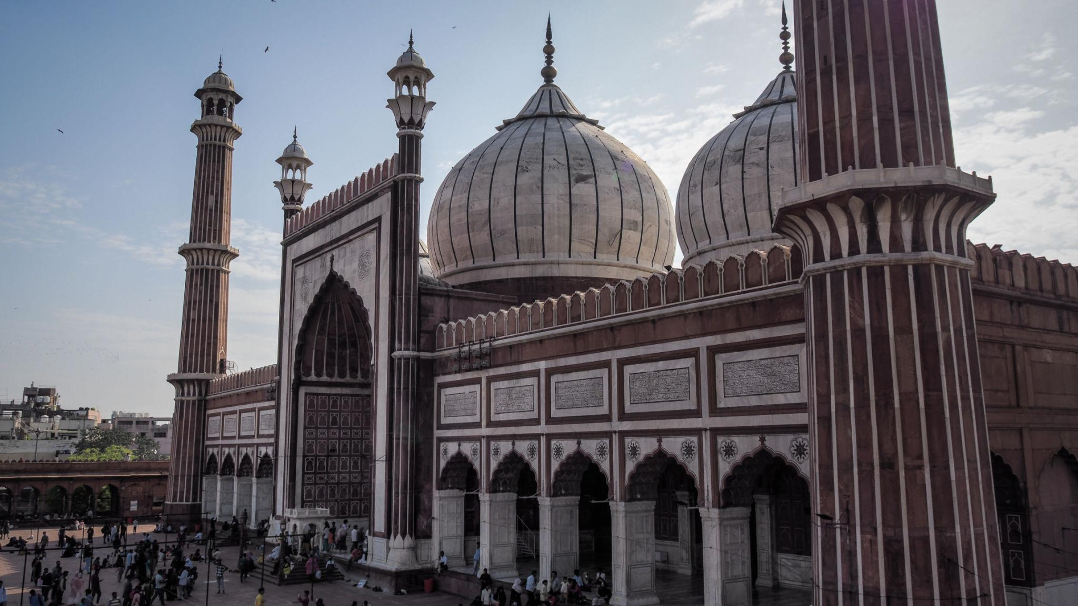
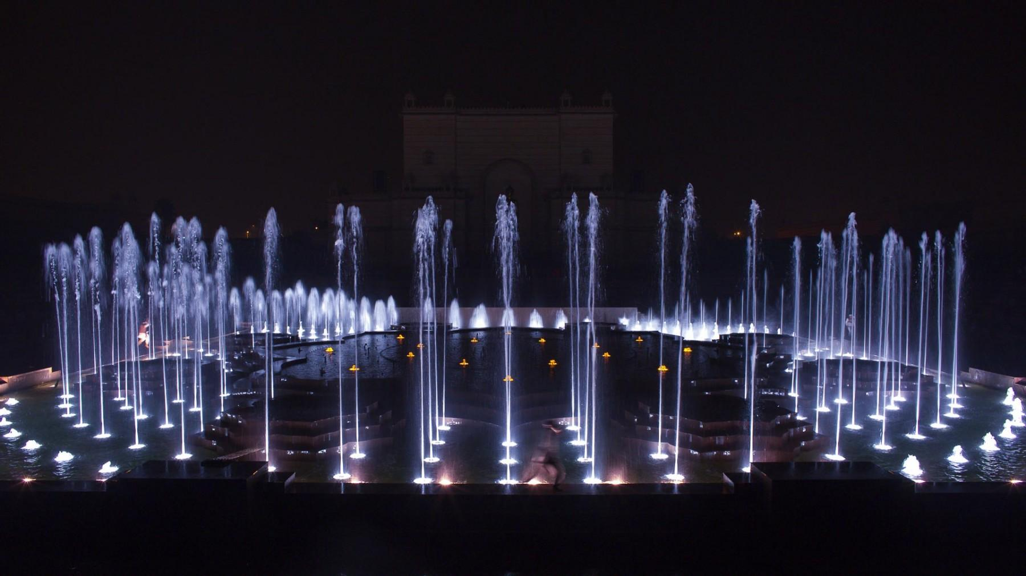

Best Things to Do in Delhi
- Explore historical monuments
- Enjoy Delhi street food tours
- Shop in local markets & malls
- Visit museums & cultural centers
- Experience nightlife & cafés
- Explore Old Delhi heritage lanes
- Attend cultural festivals
- Enjoy evening walks at India Gate

Famous Markets & Shopping in Delhi 🛍️
Popular Shopping Places:
- Chandni Chowk
- Connaught Place
- Sarojini Nagar Market
- Dilli Haat
- Khan Market
Shop for:
- Traditional clothes
- Handicrafts
- Jewelry
- Street fashion
- Souvenirs
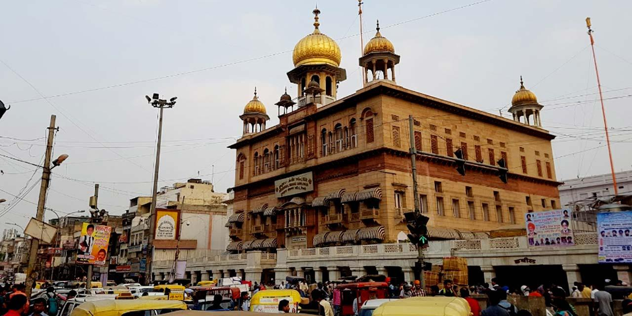
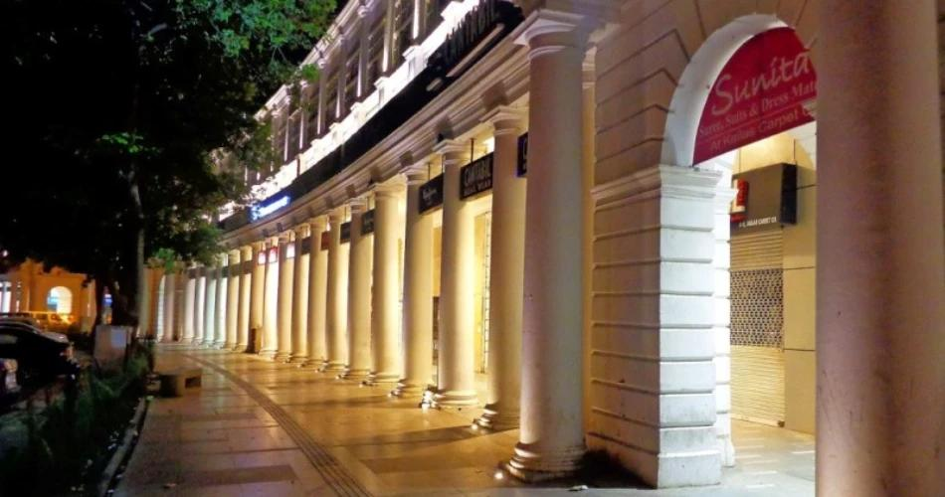
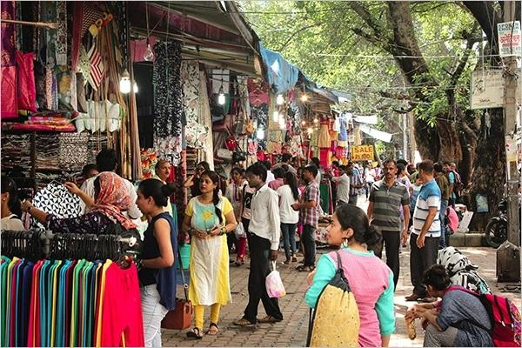
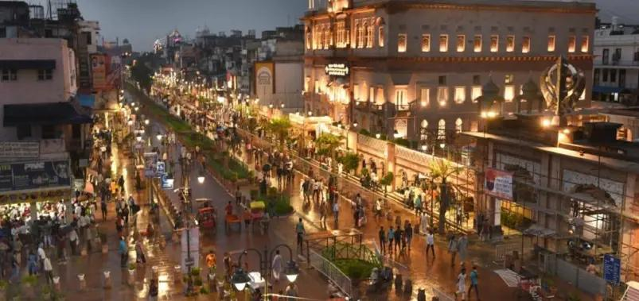
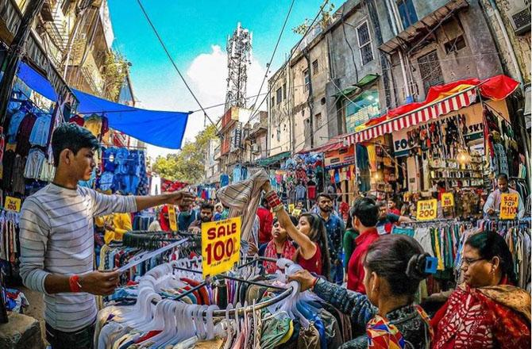
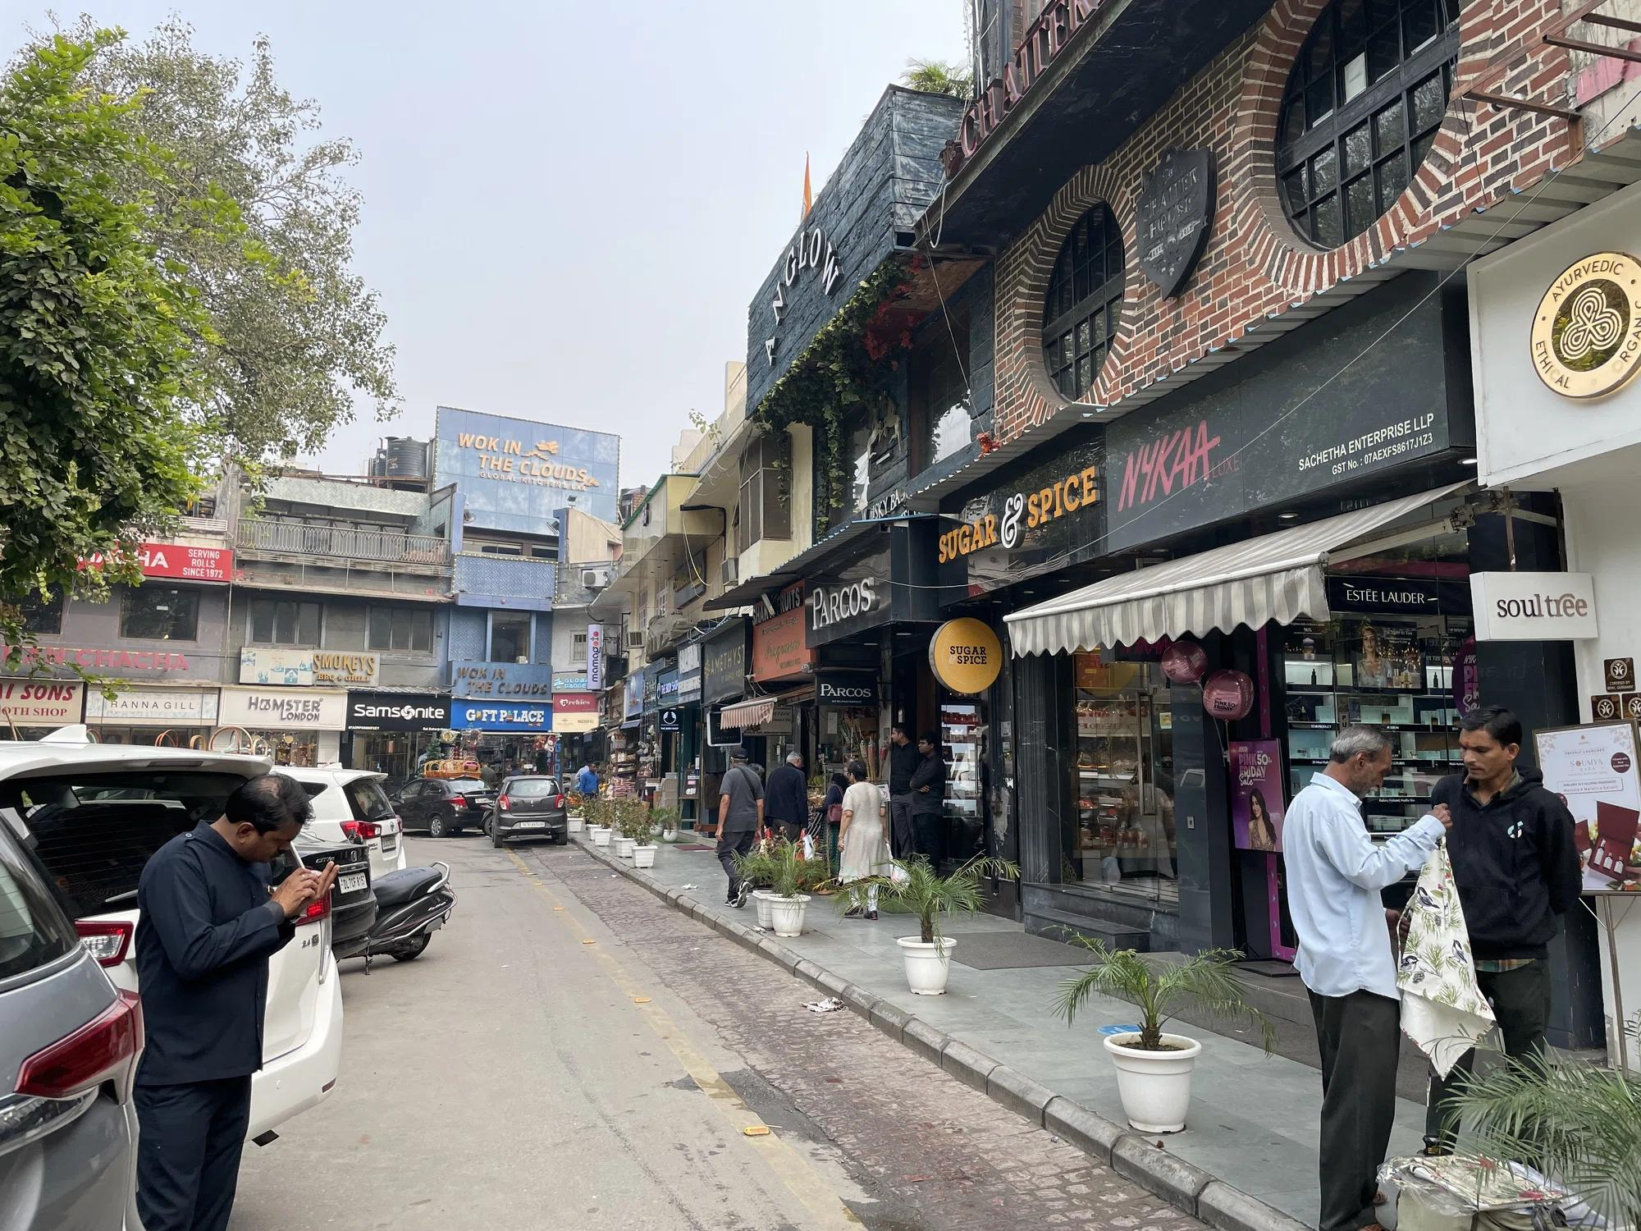

Best Time to Visit Delhi
Season | Months | Weather
Winter | October – March | Pleasant & best for sightseeing
Summer | April – June | Very hot
Monsoon | July – September | Moderate rainfall
The best season to visit Delhi is winter.

How to Reach Delhi
By Air
Main airport:
- Indira Gandhi International Airport
By Train
Delhi is connected to all major Indian cities by rail.
By Road
Excellent highway connectivity with:
- Agra
- Jaipur
- Chandigarh
- Manali
- Haridwar

Famous Foods to Try in Delhi 🍴
- Chole Bhature
- Butter Chicken
- Kebabs
- Parathas
- Golgappa
- Jalebi & Rabri
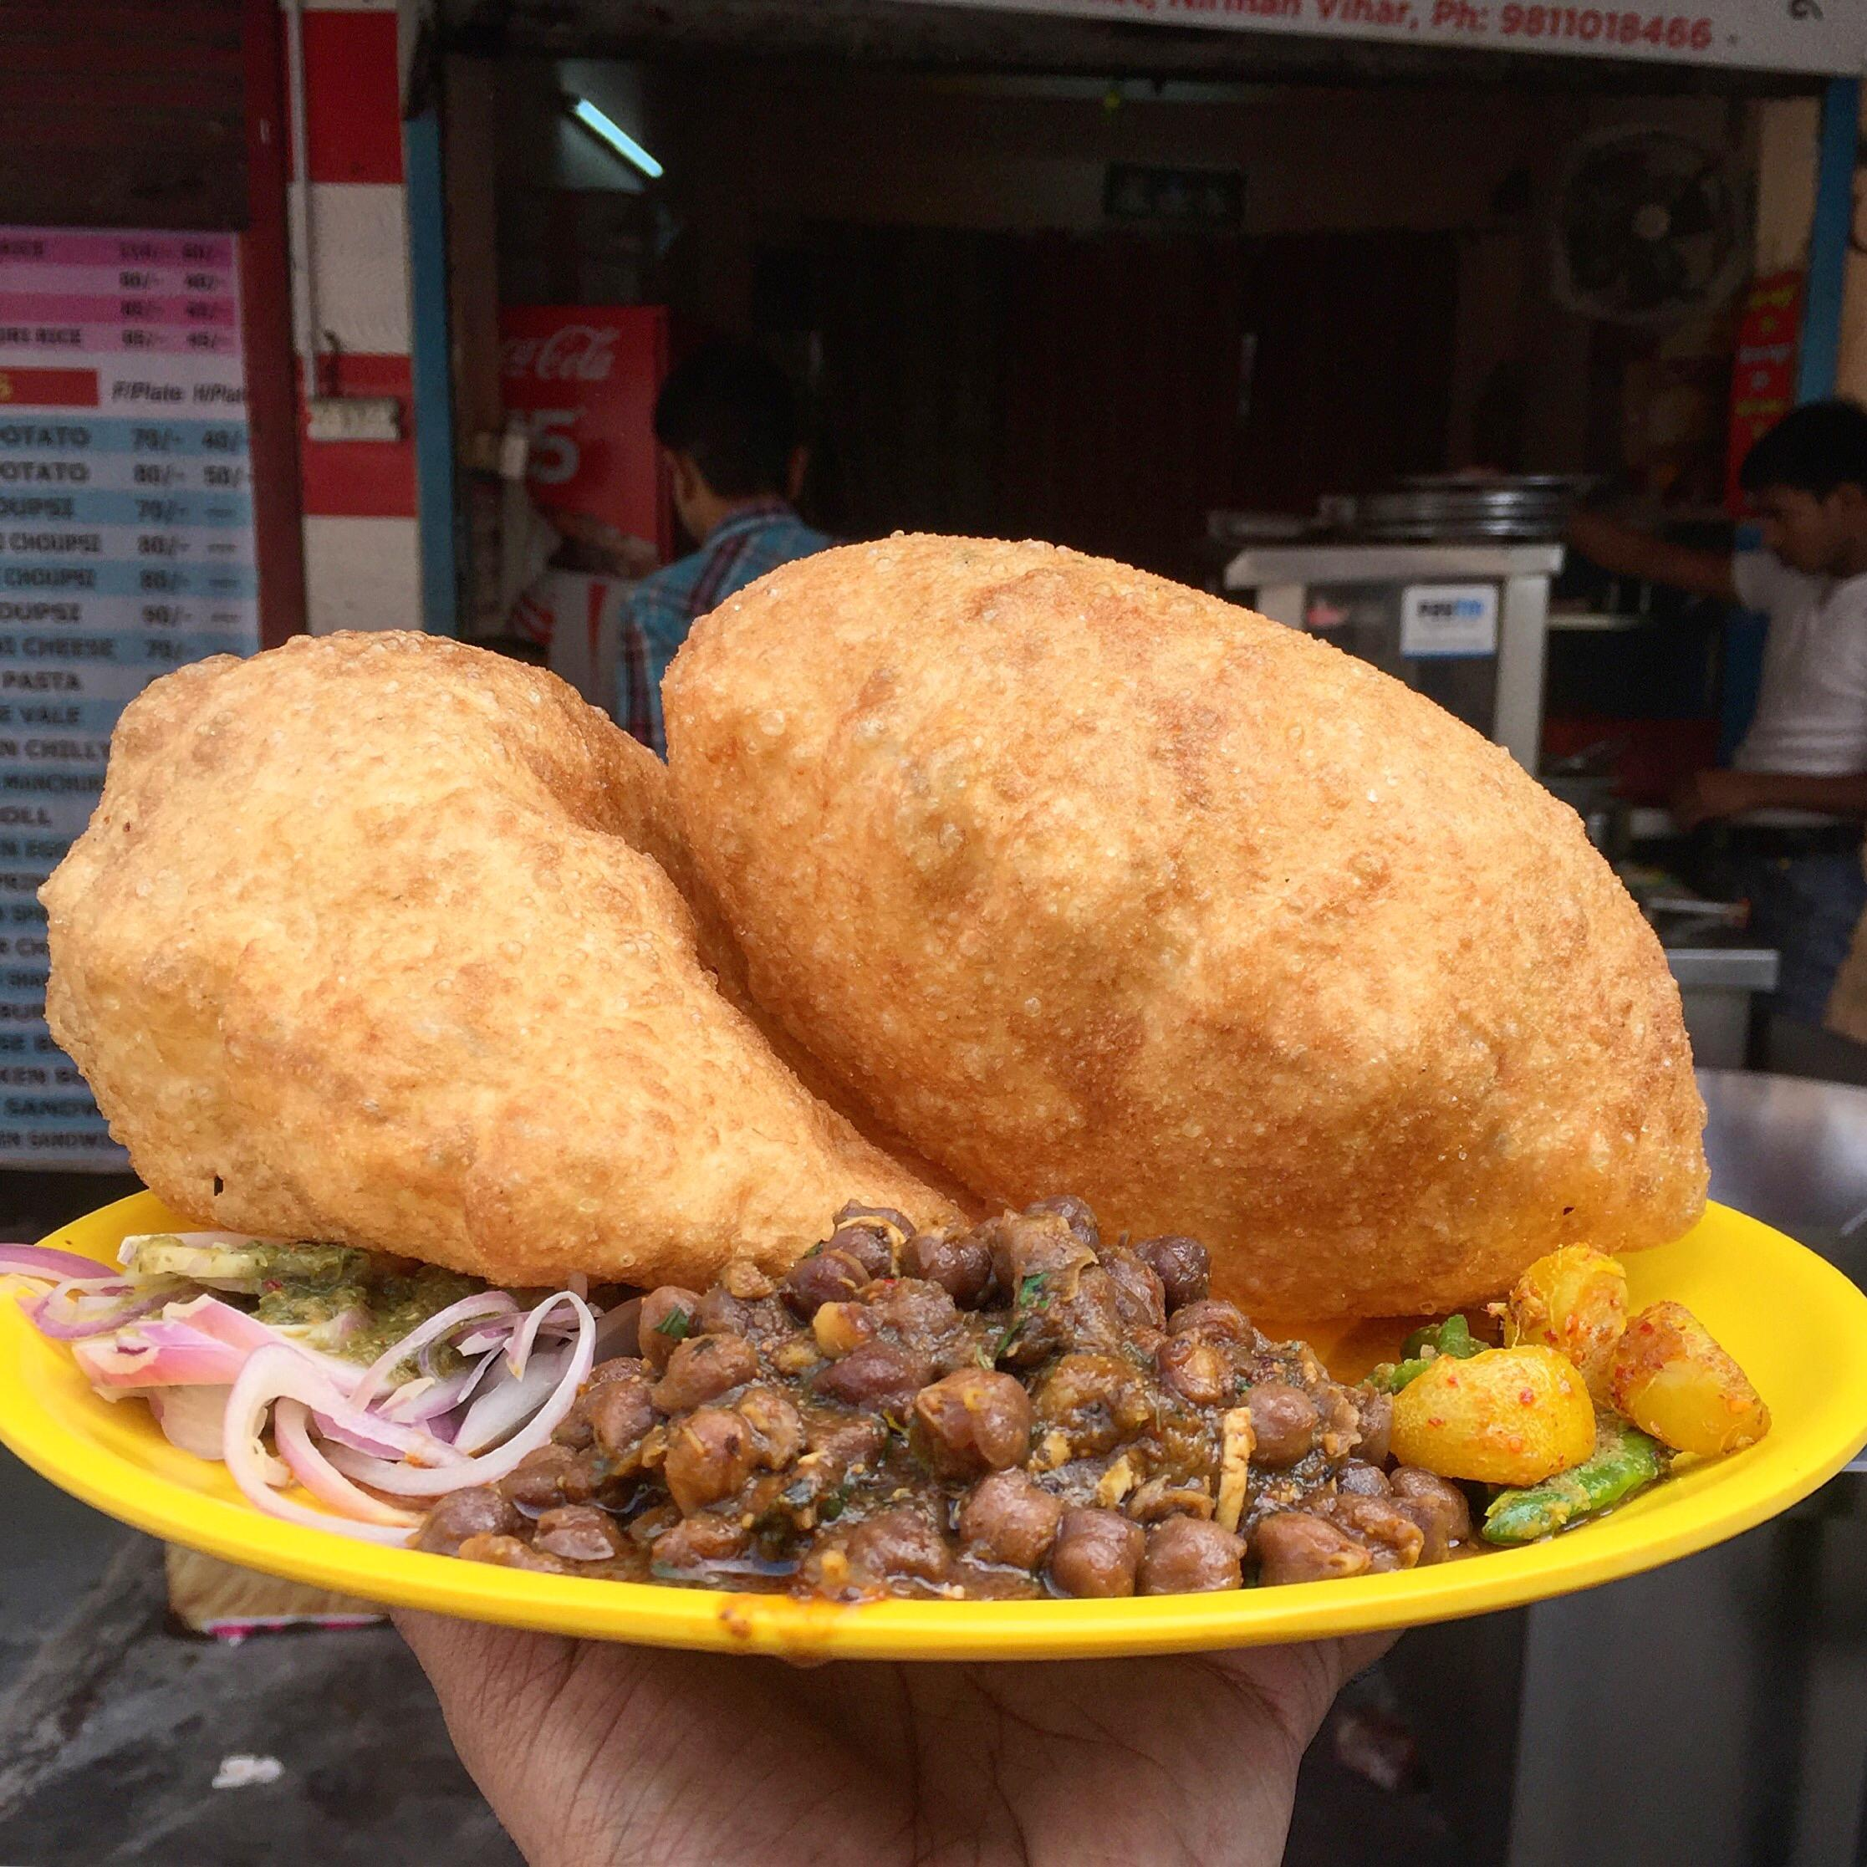
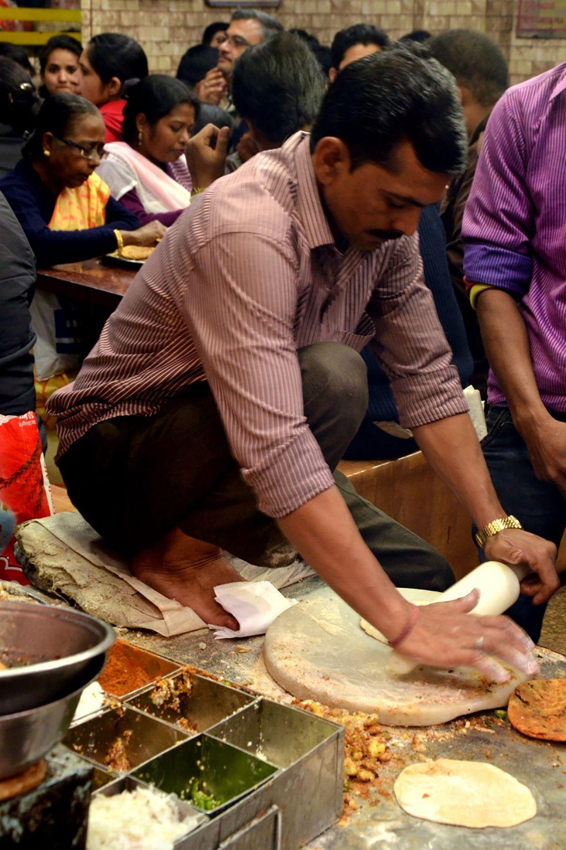
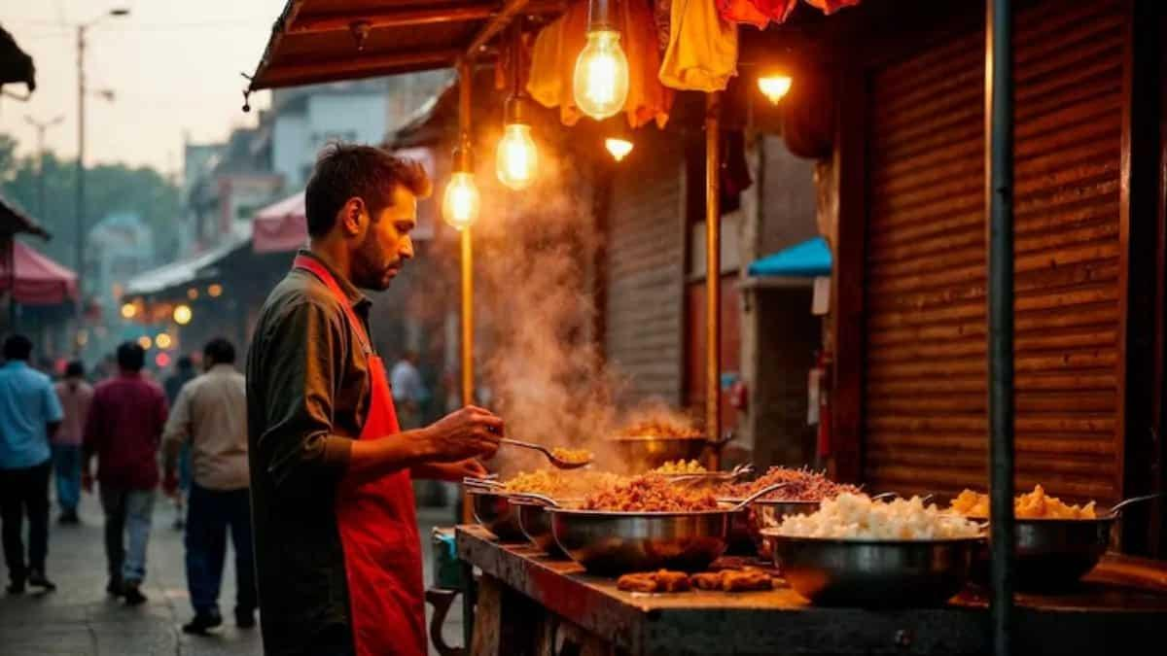
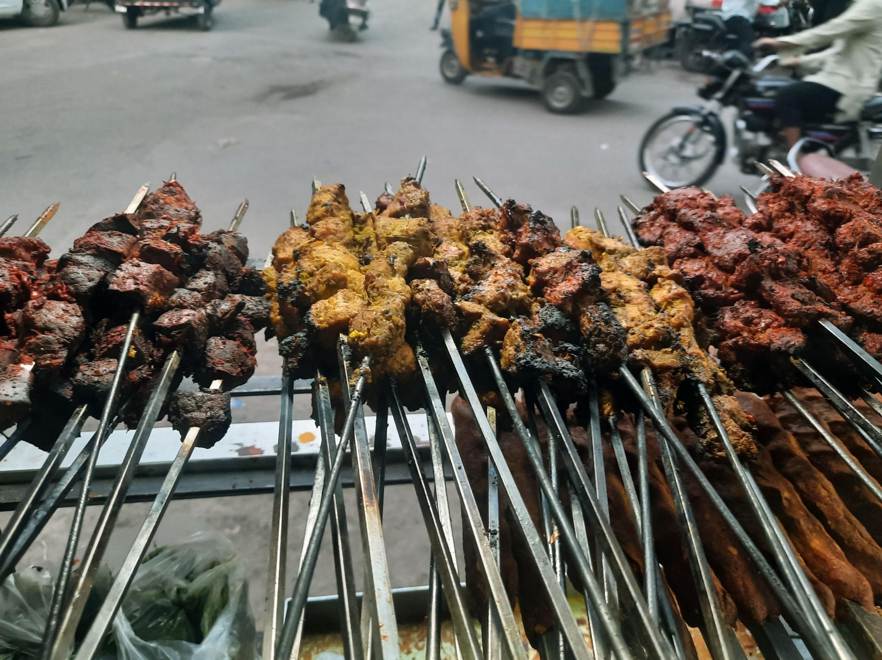
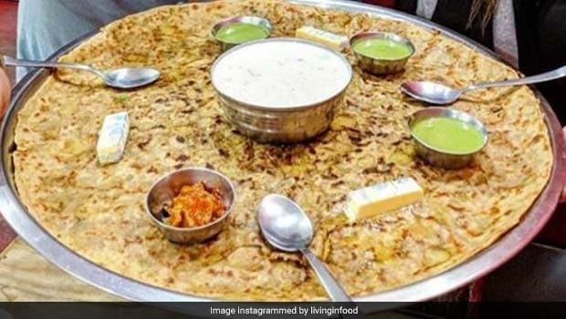
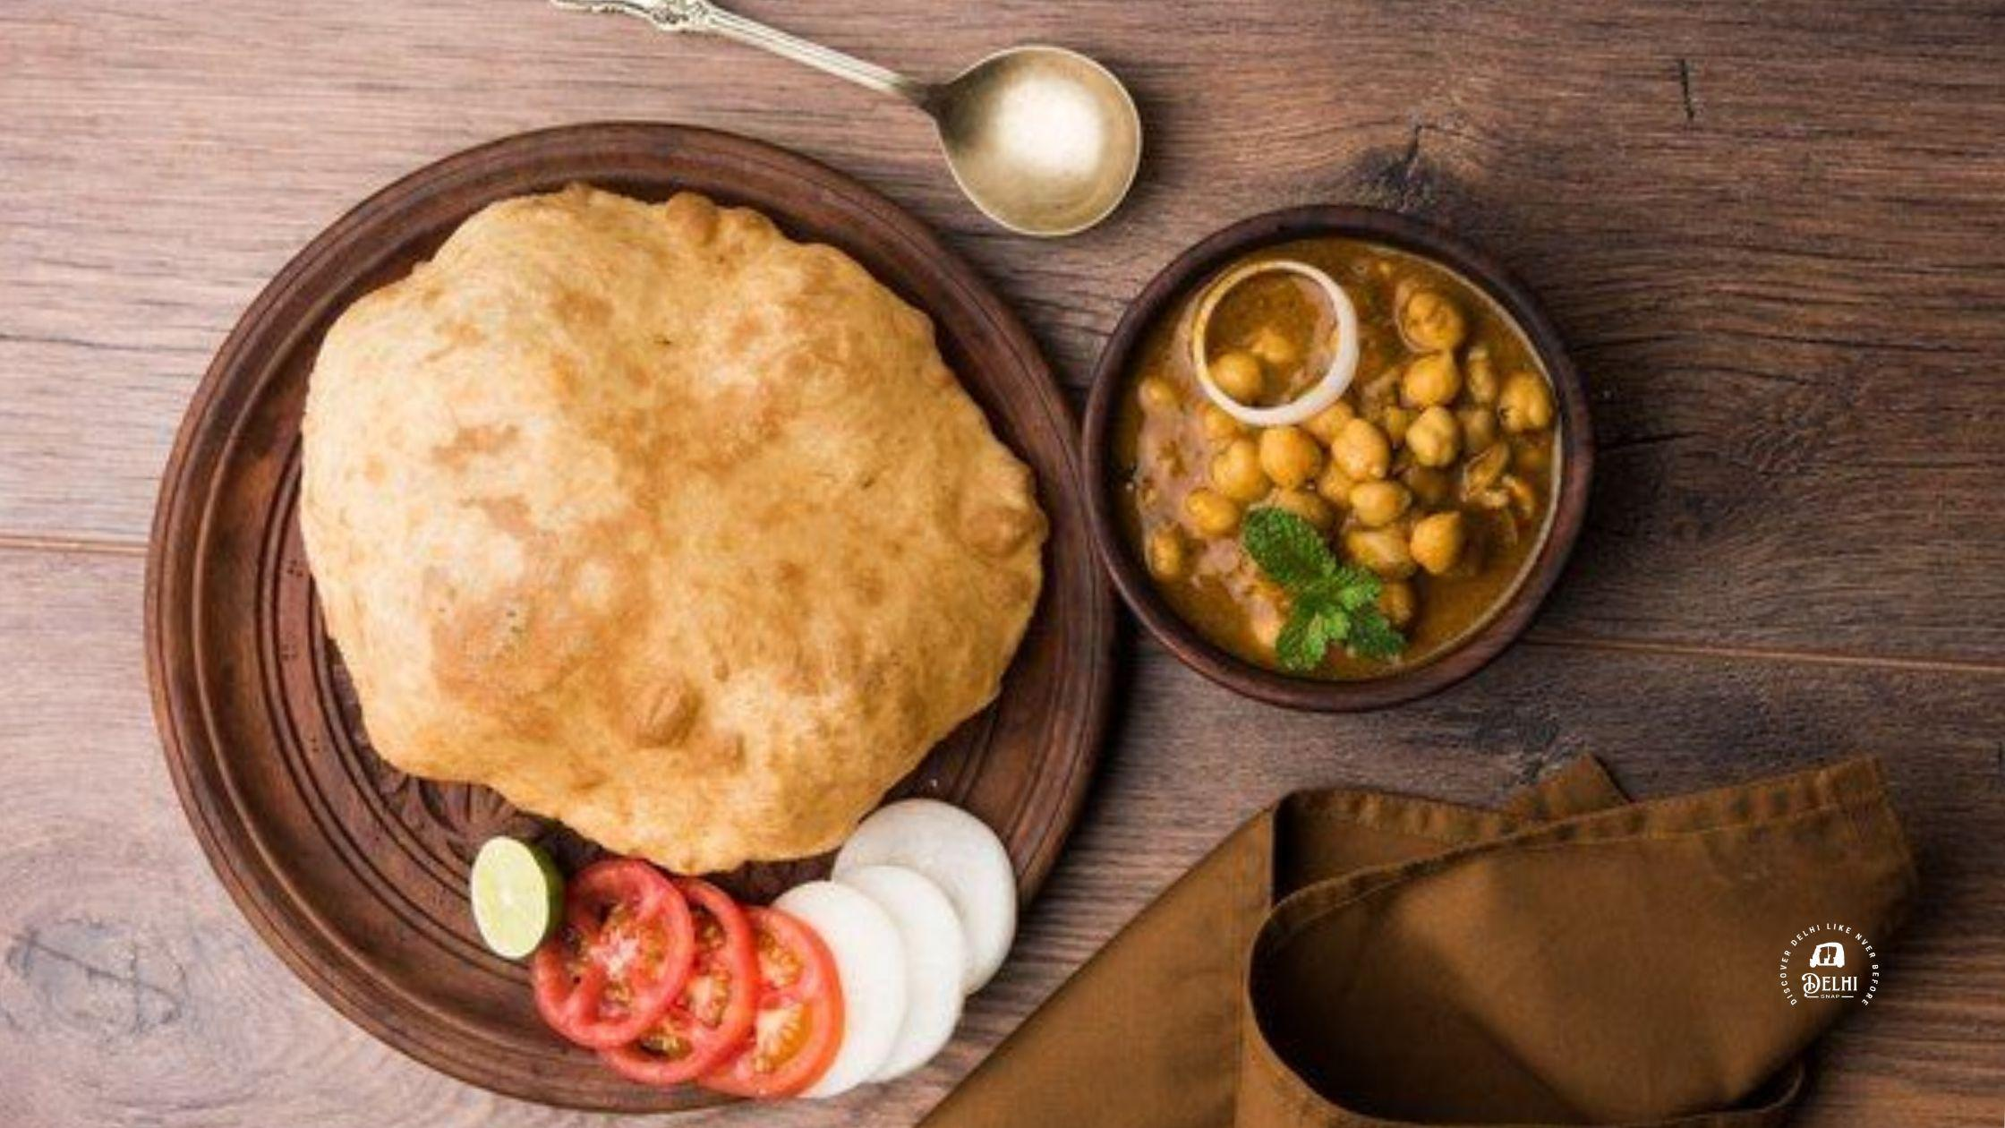
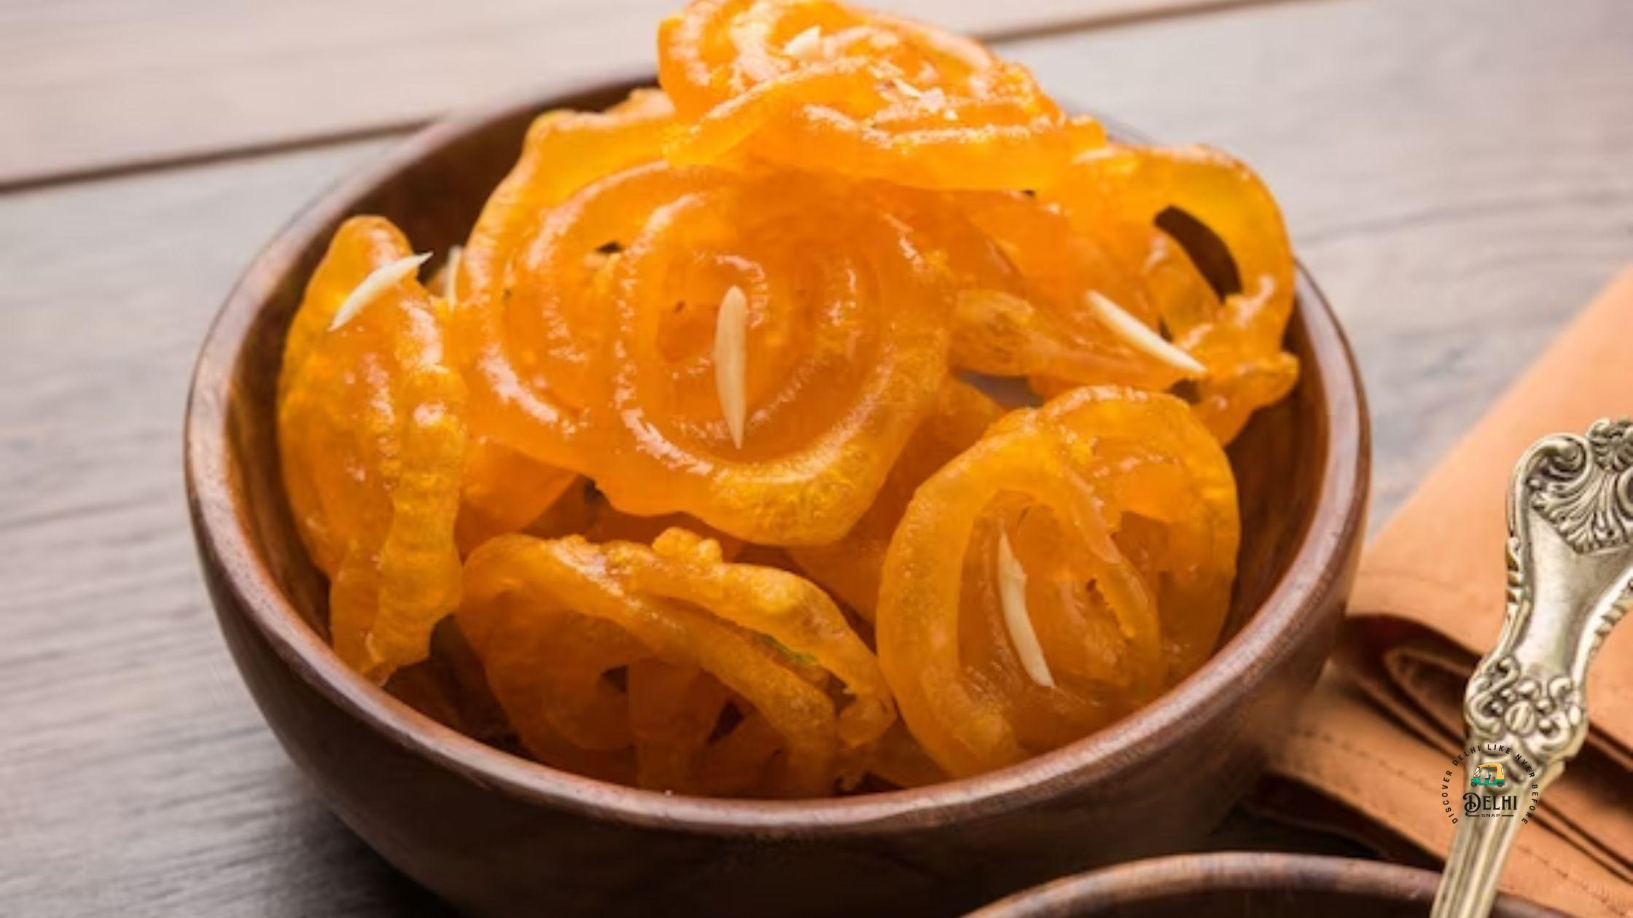

Luxury Experiences in Delhi ✨
- Luxury hotels & rooftop dining
- Heritage walks with guides
- Fine dining restaurants
- Spa & wellness experiences
- Private city tours
- Luxury shopping malls
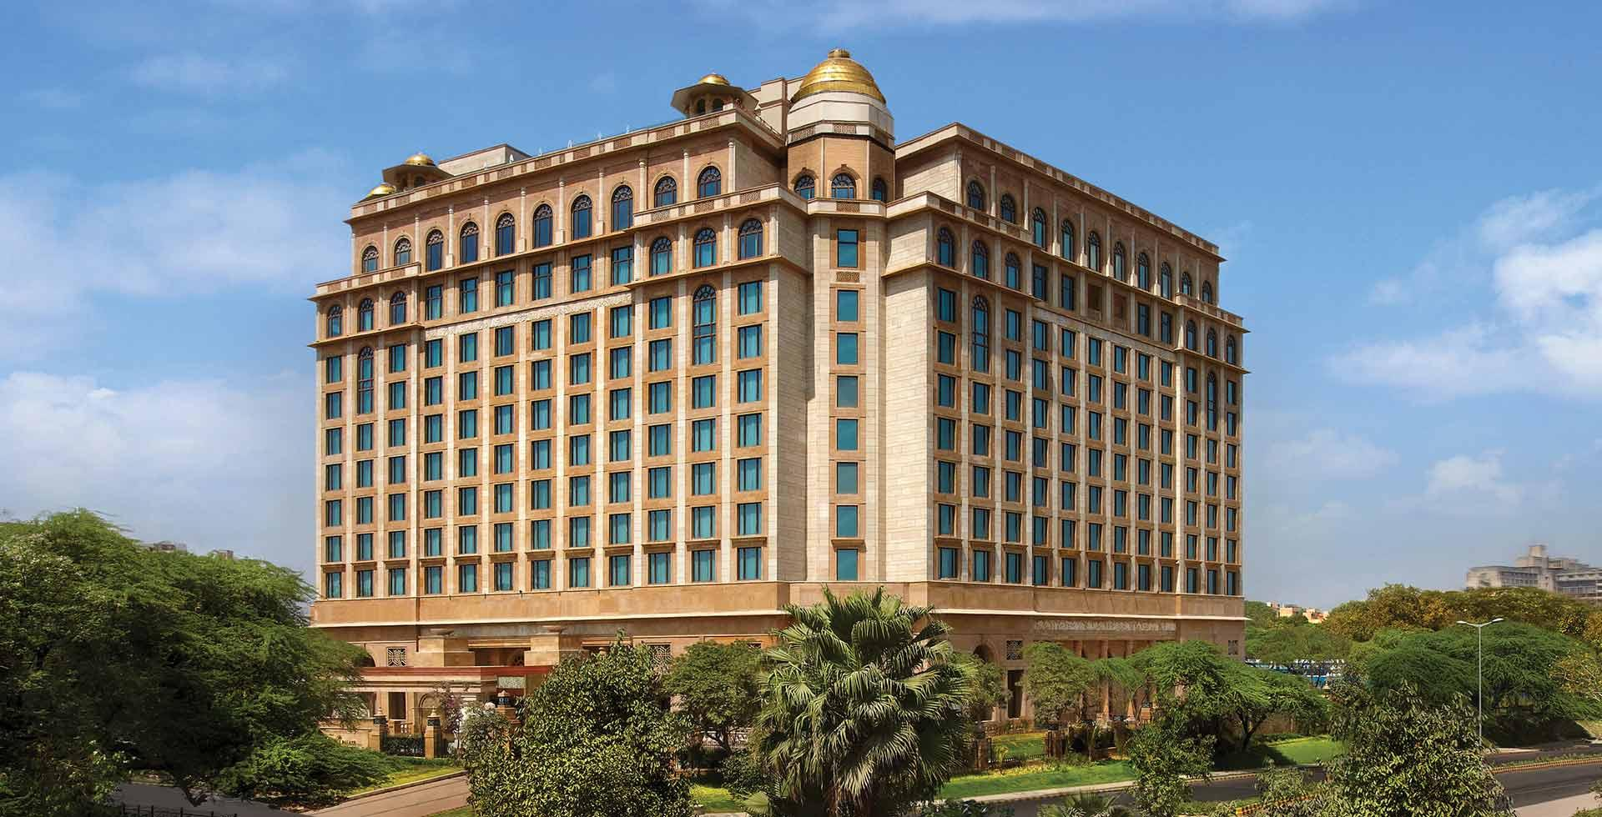
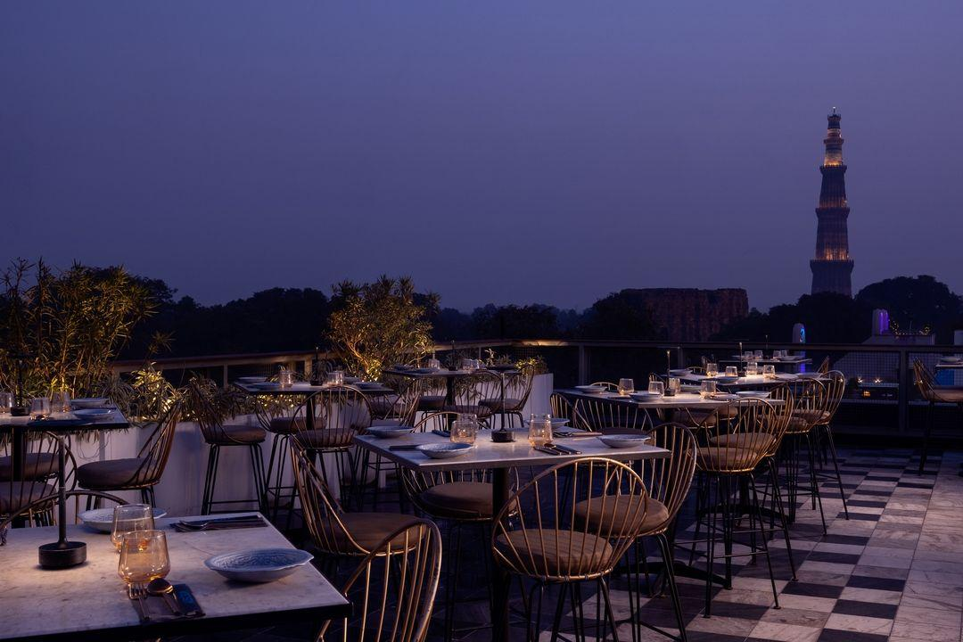
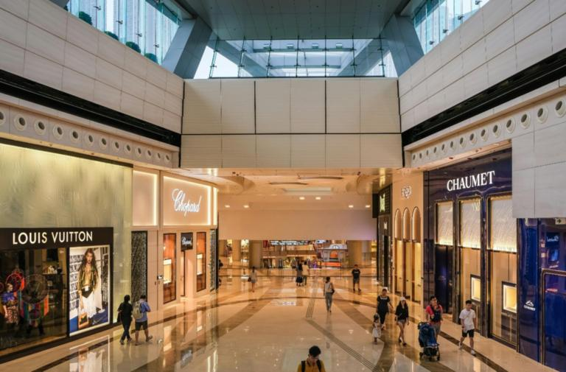
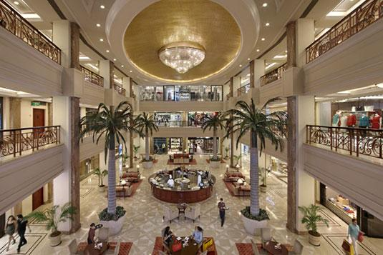
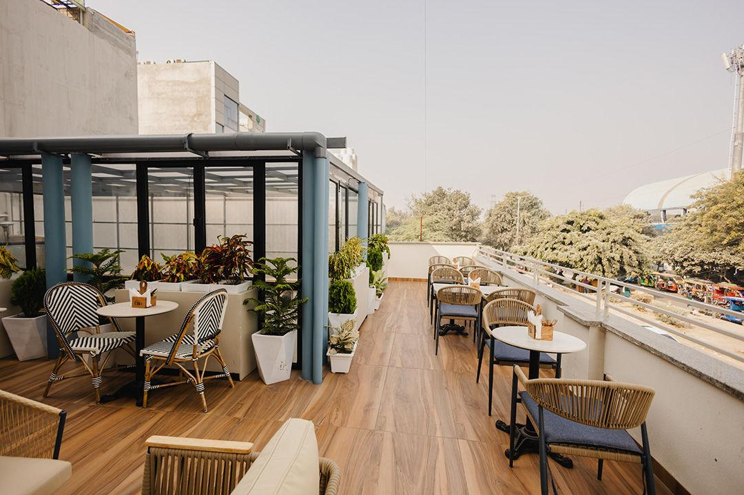

Delhi Travel Tips
- Use Delhi Metro for easy transport
- Carry comfortable walking shoes
- Visit monuments early morning
- Stay hydrated during summer
- Be cautious in crowded markets
- Carry valid ID proof

Why Choose INTRO TRAVELS INDIA for Delhi?
With INTRO TRAVELS INDIA, you get:
- Customized Delhi holiday packages
- Heritage & cultural tours
- Budget & luxury hotel options
- Guided sightseeing tours
- Airport transfers
- Food & shopping experiences
- Family & group tours
- Comfortable transport arrangements
Delhi is a destination where ancient history, vibrant culture, delicious food, shopping, and modern lifestyle come together to create an unforgettable Indian travel experience.

